GUI Elements Detection
Rodrigo Santos Magalhães
Dissertação para obtenção do Grau de Mestre em
Engenharia Informática, Área de Especialização em
Engenharia de Software

Declaration of Integrity

I hereby declare having that I have conducted this academic work with integrity.
I have not plagiarised or applied any form of undue use of information or falsification of results along the process leading to its elaboration.

Therefore, the work presented in this document is original and authored by me, having not previously been used for any other end. The exceptions are explicitly recognised in the section “Ethical considerations” of the first chapter. This section also states how AI tools were used and for what purpose.

I further declare that I have fully acknowledged the Code of Ethical Conduct of P.PORTO.

ISEP, Porto, 6 de August de 2025

Acknowledgements
I would like to begin by sincerely thanking everyone who played a crucial role in completing this project and in my academic journey overall. Looking back, there were times when reaching this milestone seemed distant and uncertain. During those moments, the constant support of friends and colleagues was a vital source of strength. It is clear that the encouragement provided, especially during the most difficult times, significantly contributed to my growth both academically and personally.
I especially want to thank my close friends, whose motivation and presence were invaluable. Miguel, I sincerely appreciate the time you dedicated to our collaborative efforts, your unwavering resilience, and your consistent support, all of which were essential to my academic progress. Most importantly, I am deeply grateful to my family my parents and brother for their unwavering love and unconditional support.
The guidance and patience of my parents laid the foundation for overcoming obstacles and reaching this important milestone. This achievement would not have been possible without your involvement.

Resumo
Esta dissertação apresenta o desenvolvimento e a avaliação de modelos de deep learning para a deteção de elementos gráficos em interfaces de utilizador (GUIs). A identificação precisa de componentes GUI, como botões, menus e campos de texto, é fundamental para o avanço da automação de testes, o aumento da acessibilidade e a facilitação da geração inteligente de interfaces. Esta investigação explora duas proeminentes famílias de arquiteturas de deteção de objetos: os detetores de fase única, exemplificados pelo YOLO, e os detetores de duas fases, especificamente o Faster R-CNN.
O projeto detalha a implementação de ambos os modelos YOLO e Faster R-CNN e conduz uma análise comparativa abrangente do seu desempenho num dataset dedicado de elementos GUI. Os modelos foram rigorosamente avaliados utilizando métricas padrão de deteção de objetos, incluindo precisão, recall, e particularmente a Média da Precisão Média (mAP) em vários limiares de Interseção sobre União (IoU) (mAP@0.50 e mAP@0.50:0.95).
Os resultados empíricos demonstram que o YOLOv11 supera significativamente o Faster R-CNN em todas as métricas avaliadas para a deteção de elementos GUI, oferecendo maior precisão e superior eficiência computacional. Esta descoberta posiciona o YOLOv11 como a escolha ótima para esta aplicação específica, provando a sua capacidade de abordar os desafios colocados pela densidade de componentes e padrões visuais variados em ambientes GUI. O estudo conclui que a abordagem escolhida avança consideravelmente a deteção de elementos GUI, fornecendo soluções práticas que contribuem para a melhoria da automação de testes de software e para o desenvolvimento de interfaces mais acessíveis e inteligentes.

Palavras-chave: deteção de elementos GUI, deep learning, Faster R-CNN, YOLO, IoU, automação de testes, acessibilidade, visão computacional.

Abstract
This dissertation presents the development and evaluation of deep learning models for the detection of graphical elements in user interfaces (GUIs). The accurate identification of GUI components, including buttons, menus and text fields, is imperative for the advancement of test automation, enhancement of accessibility and facilitation of intelligent interface generation. The present study explores two prominent families of object detection architectures: single-stage detectors, exemplified by YOLO, and two-stage detectors, specifically Faster R-CNN.
The project presents the implementation of both YOLO and Faster R-CNN models and compares their performance on a dedicated GUI element dataset. The evaluation was conducted using established object detection metrics such as precision, recall, and mean Average Precision (mAP) at multiple IoU thresholds. The results show that YOLOv11 consistently outperformed Faster R-CNN, achieving higher detection accuracy and improved inference efficiency in the context of GUI element detection.
These findings are particularly relevant for scenarios involving automated GUI analysis and interface quality assessment, where speed and accuracy are critical. Although the study does not directly implement downstream applications, the improved performance of YOLOv11 reinforces its suitability for integration in tools for automated software testing or accessibility-focused systems — directions that are identified as promising for future research.

Keywords: GUI element detection, deep learning, Faster R-CNN, YOLO, intersection over union (IoU), computer vision

Contents
1 Introduction 1
1.1 Context 1
1.2 Problem Description 2
1.3 Objectives and Research Questions 3
1.4 Ethical Considerations 4
2 Background 7
2.1 Machine Learning and Deep Learning 8
2.1.1 Convolutional Neural Networks (CNNs) 8
2.2 Object Detection in Graphical User Interfaces 10
2.2.1 Graphical User Interfaces 10
2.2.2 Object Detection 10
2.2.3 Tools and Frameworks 11
2.2.4 Evaluation Metrics 12
3 Literature Review 14
3.1 Research Questions 14
3.2 Data Sources 15
3.3 Search Terms 15
3.4 Inclusion and Exclusion Criteria 15
3.5 Data Collection Process 16
3.6 Discussion 17
3.6.1 RQ1: How accurately can deep learning models detect GUI elements across diverse platforms and layouts? 17
3.6.2 RQ2: What are the limitations and scalability challenges of applying deep learning models to large-scale GUI datasets, and how can they be addressed? 20
4 Implementation 23
4.1 Dataset Preparation 23
4.1.1 Source and Characteristics of the Dataset 23
4.1.2 Annotation Process with Label Studio 23
4.1.3 Dataset Organisation and Splitting 26
4.2 YOLO Implementation 26
4.2.1 Development Environment Setup 26
4.2.2 Dataset Preparation and data.yaml 27
4.2.3 Training Process 28
4.2.4 Inference on Unseen Images 29
4.2.5 Comparison Between YOLOv8, YOLOv10, and YOLOv11 30
4.2.6 Challenges and Optimisations 34
4.3 Faster R-CNN Implementation 35
4.3.1 Environment and Tools 36
4.3.2 Conversion to COCO Format 36
4.3.3 Architecture and Backbone 37
4.3.4 Training and Evaluation Process 39
4.3.5 Performance Evaluation 44
4.3.6 Challenges and Optimisations 46
4.4 Technical Discussion 47
4.4.1 General Comparison Between YOLO and Faster R-CNN 47
4.4.2 Final Model Selection and Justification 48
5 Evaluation 50
5.1 Architectural Differences 50
5.1.1 Specific Challenges with Fast R-CNN 51
5.1.2 Speed and Computational Efficiency 51
5.1.3 Generalisation and Robustness 52
5.1.4 Optimal Model for GUI Element Detection 52
5.2 Next Steps and Future Work 52
5.2.1 Model Refinement and Dataset Expansion 52
5.2.2 Broader Applications and Integration 53
5.2.3 Advanced GUI Understanding 53
6 Conclusion 55
6.1 Achievements and Contributions 55
6.2 Difficulties 55
6.3 Threats to Validity 56
6.4 Future Work 56
6.5 Final Considerations 57

List of Figures
Figure 1 – Typical Components of CNN Architecture [10] 9
Figure 2 – GUI Example 10
Figure 3 - Example of detection of graphical elements in GUIs using Deep Neural Network for mobile applications. [2] 11
Figure 4 - Formula illustrating the intersecting reason for the integrity union [2] 13
Figure 5 - PRISMA Systematic Methodology from [23] 17
Figure 6 - Performance non-text elements detection (IoU > 0.9) [1] 18
Figure 7 - Performance at different IoU thresholds [1] 19
Figure 8 - Overall results of object detection (IoU>0.9) [1] 20
Figure 9 - - Models Performance Comparison [20] 20
Figure 10 - Object Detection Pipeline in YOLOv4 21
Figure 11 - Parameter Server Architecture [25] 22
Figure 12 - AllReduce Architecture [25] 22
Figure 13 - Illustration of distributed deep learning training, showing model splitting, batch data input, parallel processing, and parameter synchronization. [26] 23
Figure 14 - Illustration of distributed deep learning training, showing model splitting, batch data input, parallel processing, and parameter synchronisation. [25] 24
Figure 15 – Process of Labelling Images 29
Figure 16 – Structure YOLO Annotation 29
Figure 17 – Example of YOLO Annotation 29
Figure 18 - YOLO model results template 34
Figure 19 - YOLOv11 model results 35
Figure 20 – YOLOv10 model results 36
Figure 21 - YOLOv8 model results 37
Figure 22 – Fast R-CNN Model Results 50
Figure 23 – Result from Best Model of YOLO 54

List of Tables
Table 1 – Data Sources 16
Table 2 – GUI Component Classes 28
Table 3 – Comparison of Results between YOLO Models 38

List of Snippets
Snippet 1 – Create data.yaml 31
Snippet 2 - Command to create YOLO model 32
Snippet 3 – Command to use the model in a image 33
Snippet 4 – Fast R-CNN Model Creation 41
Snippet 5 – Fast R-CNN Optimiser and LSR 42
Snippet 6 – Fast R-CNN Transform Images 44
Snippet 7 – Fast R-CNN Create Train and Validation Dataset 44
Snippet 8 – Fast R-CNN Model Trainning 45
Snippet 9 – Fast R-CNN Model Evaluation 46
Snippet 10 - Fast R-CNN Save training history 48
Snippet 11 – Fast R-CNN Evaluation Diagram Creator 49

Abbreviations and Symbols
Abbreviations list
CNN – Convolutional Neural Network
IoU – Intersection over Union
mAP – Mean Average Precision
GUI – Graphical User Interface
R-CNN – Region-based Convolutional Neural Network
YOLO – You Only Look Once
SSD – Single Shot Multibox Detector
EDA – Exploratory Data Analysis
GPU – Graphics Processing Unit
API – Application Programming Interface
GDPR – General Data Protection Regulation
HCI – Human-Computer Interaction
PRISMA – Preferred Reporting Items for Systematic Reviews and Meta-Analyses
NMS – Non-Maximum Suppression
AWS – Amazon Web Services
RAM: Random Access Memory
VRAM: Video Random Access Memory
FPN: Feature Pyramid Network
RPN: Region Proposal Network
UI: User Interface
CPU: Central Processing Unit
I/O: Input/Output

Symbols list
IoU - 𝑰𝒐𝑼 = 𝑨𝒓𝒆𝒂 𝒐𝒇 𝑶𝒗𝒆𝒓𝒍𝒂𝒑, intersection relationship on the union
𝑨𝒓𝒆𝒂 𝒐𝒇 𝑼𝒏𝒊𝒐𝒏

mAP – Average accuracies for different classes and overlap thresholds
F1-score - 𝑭𝟏 = 𝟐 . 𝑷𝒓𝒆𝒄𝒊𝒔𝒊𝒐𝒏.𝑹𝒆𝒄𝒂𝒍𝒍, average between precision and recall
𝑷𝒓𝒆𝒄𝒊𝒔𝒊𝒐𝒏+𝑹𝒆𝒄𝒂𝒍𝒍

Introduction
This project was conceived and executed for the Dissertation course in the year of the master’s in informatics engineering (MEI) programme at Instituto Superior de Engenharia do Porto (ISEP). The subsequent chapter will provide a comprehensive overview of the pertinent background and context, delineating the problem under investigation. The dissertation will present its research objectives and discuss ethical considerations. The following section will provide a detailed overview of the report's structure.

Context
The rapid progress in computer vision and deep learning has significantly influenced multiple fields, including autonomous systems, healthcare, and software engineering. A notable emerging field in which the application of computer vision is becoming increasingly evident is the automated detection of graphical user interface (GUI) components [1][2]. The utilisation of graphical user interfaces (GUIs) in contemporary software applications is of paramount importance, as they constitute the predominant medium through which users engage with the systems [3]. It is imperative to ensure the precision, usability and operational integrity of these interfaces to enhance the user experience and maintain software quality standards.
However, automating the detection and validation of GUI elements presents distinct challenges compared to traditional object detection tasks [1]. GUIs often consist of densely packed components, overlapping elements, and hierarchical structures that lack clear visual boundaries [2][4]. This inherent complexity can hinder the effectiveness of conventional object detection models, which are optimised for recognising separate objects within natural images [5][6].

The ability to recognise graphical user interface (GUI) elements is vital for various applications, including automated software testing and the efficient development of user interfaces [7][8]. In the context of automated testing, accurately identifying buttons, text fields, and menus is imperative for simulating user interactions. This approach has been demonstrated to reduce the necessity for manual testing efforts and to enhance the reliability of the testing process [9]. Additionally, automated GUI detection can streamline the interface design process by enabling tools that generate interface layouts based on existing components [10].
Notwithstanding the potential benefits, current approaches are encumbered by limitations in accurately detecting GUI elements across diverse platforms, including mobile, web, and desktop environments [2][7]. The paucity of large, annotated datasets, in conjunction with the variability in GUI designs, serves to complicate the development of robust models further [1][11]. Existing datasets provide a valuable foundation, but they often lack coverage of less standard or custom-built interfaces, leading to gaps in model generalisation [7].
This project aims to address these challenges by studying deep learning techniques with traditional image processing methods and leveraging datasets to train and validate the proposed model [2]. This study seeks to advance software testing and interface development automation by bridging the gap between computer vision and GUI analysis, providing practical solutions for the software engineering and human-computer interaction communities.

Problem Description
Accurately detecting graphical user interface (GUI) elements is crucial to software development, as it influences automated testing, accessibility, and the generation of user interface (UI) [1][2][7]. The following text is intended to provide a comprehensive overview of the subject matter. As software interfaces become more complex, with elaborate layouts, dynamic features, and hierarchical structures, accurately recognising GUI components presents substantial difficulties. Traditional object detection models have successfully identified real-world objects but encounter challenges when applied to GUIs [5][6]. These models often struggle with overlapping elements, ambiguous visual boundaries, and the dense arrangement of components characteristic of user interfaces [2][4].
Furthermore, the absence of standardised datasets and annotations specific to GUI detection limits the development and training of robust models [1][7][11]. Existing datasets offer a valuable starting point but fail to cover the full diversity of platforms, device types, and interface designs encountered in practice [7][10]. This absence of diversity can compromise the generalisability of the model, resulting in diminished accuracy during the detection of GUI elements across diverse applications and environments.
Another critical issue lies in the hierarchical and contextual nature of GUI elements. Unlike natural objects, GUI components often exist in nested relationships (e.g., buttons within menus and tabs within panels) [2]. Current object detection models typically focus on detecting individual components without considering the broader structural and contextual relationships that define GUI layouts [7][6

Objectives and Research Questions
This research aims to develop and evaluate a model that accurately identifies GUI elements, tackling challenges such as component density, overlap, and hierarchy. Future enhancements to this project could lead to progress in automated software testing, accessibility, and interface generation.
Objectives
- Study a hybrid model that integrates convolutional neural networks (CNNs) with traditional image processing techniques to detect GUI components.
- Improve detection accuracy for overlapping and hierarchically organised elements by leveraging datasets.
- Evaluate model performance using key metrics, including precision, recall, F1-score, intersection over union (IoU), and mean average precision (mAP).
- Ensure the model's generalisation across different GUI environments, such as mobile, web, and desktop platforms.
Research Questions
- RQ1: How accurately can deep learning models detect GUI elements across diverse platforms and layouts?
- RQ2: What are the limitations and scalability challenges of applying deep learning models to large-scale GUI datasets, and how can they be addressed?
- RQ3: How can deep learning models such as YOLO and Faster R-CNN be effectively implemented and trained for the specific task of GUI element detection using real annotated datasets?
The objective of this research is to address the limitations in GUI detection by proposing a robust solution that enhances the efficiency and accuracy of automated interface analysis, thereby supporting a wider range of applications in software development and human-computer interaction.

Ethical Considerations
This project is based on a strong commitment to ethical research practices, ensuring that all activities are carried out responsibly, transparently, and in accordance with relevant legal and institutional standards. Although the research does not involve direct interaction with human participants or the management of personal or sensitive data, several critical ethical considerations have been taken into account during the development of the work:
- Data Protection and Information Security
  - All datasets used in this study are either publicly available or synthetically generated for academic use. No personal data or sensitive information will be collected, stored, or processed at any stage. Full compliance with the General Data Protection Regulation (GDPR) is maintained. When data augmentation or annotation is necessary, suitable measures will be implemented to protect anonymity and prevent any identifiable elements from being included.
- Transparency and Reproducibility
Relativamente ao comentário que tenho, não é novo. Exemplo da última revisão:
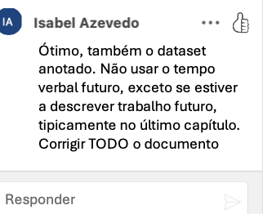
Gostaria que me explicasse na próxima reunião porque não o considerou.
  - The project will be thoroughly documented to ensure complete traceability of its methodologies, tools, and experimental procedures. By applying open science principles, all relevant resources, including code, data, and experimental results, will be made publicly accessible in a dedicated repository, licensed to permit reuse and modification by the broader research community. This encourages collaborative development and enhances the reproducibility of findings.
- Fairness and Mitigation of Bias
  - Special attention will be given to avoiding bias in both data selection and model training. Diverse and representative datasets will be prioritised to ensure fair performance across different scenarios. The outputs of the models will be regularly reviewed to identify and address any discriminatory patterns, supporting inclusive and equitable outcomes in the application of the technology.
- Institutional and Professional Standards
  - The project complies with the Code of Good Practice of the Polytechnic Institute of Porto, which sets out principles of academic integrity, intellectual honesty, and respect for authorship. Additionally, the ethical guidelines established by the Portuguese Engineers’ Order, especially the Code of Ethics and Deontology, will be observed. These frameworks guarantee that engineering solutions are developed responsibly and in alignment with societal well-being.
- Social Responsibility in Software Engineering
  - Beyond the technical objectives, the research considers the broader societal implications of graphical user interface (GUI) detection technologies. Particular attention is given to their possible use in assistive technologies and automated testing, where responsible innovation can have a direct and meaningful impact.
- Prevention of Research Misconduct
  - Strict safeguards are in place to prevent academic misconduct such as data fabrication, falsification, or plagiarism. All contributions from external sources will be appropriately credited, and original developments within the project will be clearly distinguished.
- Ongoing Ethical Oversight
  - Ethical review will be an ongoing process throughout the project. Any major changes to the methodology or scope of the research will undergo internal assessment to identify potential ethical concerns and to ensure the project remains aligned with best ethical standards.
The project aims to maintain the highest ethical standards in research and software engineering, foster trust, and contribute to the broader academic and professional community by adhering to these principles.

Background
This chapter provides the theoretical foundations necessary to understand the development of models for detecting graphical elements in user interfaces (GUIs) using deep learning techniques. The structure of the chapter is organised to follow a progressive path, starting from general concepts and gradually focusing on the specific methodologies applied in this work.
Section 2.1 introduces the concept of graphical user interfaces, highlighting their relevance in software development and the motivation for automating their analysis.
Section 2.2 explains the object detection task, detailing its core components—localisation and classification—and its challenges in GUI environments.
Section 2.3 covers the family of YOLO (You Only Look Once) models, describing their evolution and why they are suitable for real-time object detection in GUI contexts.
Section 2.4 discusses Convolutional Neural Networks (CNNs), outlining their architecture and role as the basis for modern detection models.
Section 2.5 describes the evaluation metrics used in the project, such as IoU, Precision, Recall, and mAP, providing the essential understanding needed to evaluate model performance.
Section 2.6 outlines the Faster R-CNN architecture, which serves as a baseline for comparison with YOLO models, and highlights its core components and detection strategy.
Section 2.7 reviews the tools and frameworks utilised throughout the project, including PyTorch, Label Studio, Google Colab, and supporting libraries used for annotation, training, and evaluation.
Lastly, Sections 2.6 and 2.7 present the fundamental principles of machine learning, alongside the tools and frameworks adopted in the project, shedding light on the computational environment and techniques underpinning the implementation.

Machine Learning and Deep Learning
Machine learning is a subset of artificial intelligence that enables systems to learn patterns from data and make predictions without explicit programming. In GUI element detection, machine learning techniques recognise and classify interface components by training models on large datasets of annotated GUI images [19].
The process typically involves supervised learning, where labelled datasets teach the model to identify GUI components. Rectangular frames and corresponding labels accompany each image, the purpose of which is to meticulously delineate the spatial coordinates and semantic class of the graphical user interface elements. As the model iteratively processes this annotated data, it undergoes a process of self-optimisation, systematically adjusting its internal parameters to mitigate prediction discrepancies, consequently enhancing the accuracy of its inferences over time.
A range of machine learning (ML) algorithms is employed in the context of GUI detection, with deep learning models, particularly convolutional neural networks (CNNs), emerging as the most efficacious solution for image-based tasks. Convolutional neural networks (CNNs) have been shown to excel at detecting patterns and spatial hierarchies, making them ideal for analysing complex graphical user interface (GUI) layouts [19].
In addition to CNNs, transfer learning is frequently employed, whereby pre-trained models (trained on extensive image datasets) are fine-tuned for GUI-specific tasks. This decrease in required data and computational resources provides two main benefits. Firstly, it accelerates development. Secondly, it supports maintaining accuracy.
Machine learning also enables real-time detection using models such as YOLO and SSD. These models process entire images in a single pass, allowing GUI components to be detected quickly and efficiently during software testing or runtime [20]

Convolutional Neural Networks (CNNs)
Convolutional Neural Networks (CNNs) are the backbone of modern computer vision, enabling the accurate detection and classification of visual patterns. Convolutional neural networks (CNNs) are a specialised type of deep neural network designed to process image data by applying convolutional layers that extract features such as edges, shapes, and textures. The network then combines and interprets these extracted features to recognise objects within an image [16].
The architecture of a CNN usually consists of several convolutional layers, followed by pooling layers that decrease the spatial dimensions of the feature maps. This process maintains crucial information while discarding irrelevant details, enabling the network to concentrate on critical visual features. Fully connected layers at the network's end interpret the extracted features and make predictions [10].
Figure 1 illustrates the typical architecture of a CNN used in GUI element detection. The process begins with the input image, which passes through several convolutional layers where essential features are extracted. Max pooling layers reduce the dimensionality of feature maps, ensuring that the most important patterns are retained. The final part of the process involves integrating fully connected layers to classify the detected elements and generate predictions, such as buttons, text views, and checkboxes.
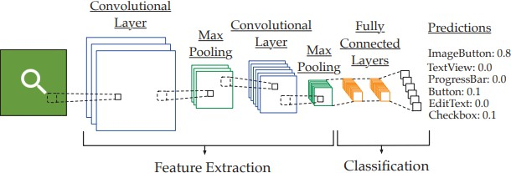
Figure 1 – Typical Components of CNN Architecture [10]
CNNs excel at tasks involving pattern recognition, making them ideal for object detection applications. They have been successfully applied to detect GUI components by analysing screenshots or video frames of user interfaces. Through the supervised training of Convolutional Neural Networks (CNNs) on annotated datasets that incorporate a range of diverse GUI layouts, the model has been shown to acquire the capability to identify constituent elements precisely.
A range of Convolutional Neural Network architectures has emerged to address the challenges associated with object detection tasks. Specifically designed to generate accurate region proposals, the Faster R-CNN model then applies convolutional filters to detect objects within these proposed regions precisely. This method has been shown to provide high accuracy, but it results in slower inference times. YOLO processes the entire image in a single pass, making it faster but slightly less accurate for small objects. SSD balances speed and accuracy by detecting objects at multiple scales [17].
For GUI detection, CNNs must be adapted to handle the unique characteristics of interface elements. This includes the development of models with the capacity to discern minuscule objects, effectively manage components that overlap, and robustly recognise hierarchical structures.

Object Detection in Graphical User Interfaces

Graphical User Interfaces
Graphical User Interfaces (GUIs) are integral components of modern software applications, offering a visual and interactive environment that enables users to engage with digital systems. Unlike command-line interfaces that rely on text-based commands, GUIs simplify user interactions by representing system functionalities through graphical elements [12]. These include buttons, text fields, icons, sliders, checkboxes, and dropdown menus, enabling users to navigate intuitively, input data, and execute commands with ease, as demonstrated in Figure 2.
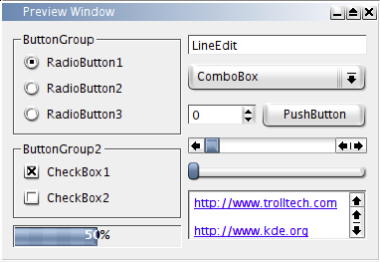
Figure 2 – GUI Example
GUI’s main aim is to improve usability by providing a more accessible and user-friendly experience. The systems allow simple interaction with complex systems by avoiding the need for extensive technical knowledge. Furthermore, the integration of Graphical User Interfaces (GUIs) within many software programmes highlights their significance in the realm of software development.
GUIs evolved from static forms to dynamic, responsive ones that adapt to diverse devices [13]. This has resulted in more complex animations, layouts and nested structures, which have significantly increased visual complexity. Consequently, identifying and examining GUI components — particularly those with overlapping or hierarchical elements — has become more challenging [7, 10].

Object Detection
Object detection is a core task in computer vision that involves identifying and localising objects within an image or video by drawing bounding boxes around them. Unlike object classification, which assigns a label to an entire image, object detection can identify multiple objects of different types within the same frame, as shown in Figure 3. This approach is more complex but versatile, making it applicable to tasks such as facial recognition, pedestrian detection, medical imaging, and autonomous vehicle navigation [2].

Figure 3 - Example of detection of graphical elements in GUIs using Deep Neural Network for mobile applications. [2]
In the context of GUIs, object detection is utilised to identify individual interface components such as buttons, menus, and input fields. The ability to accurately detect and localise these elements is crucial for automated testing, accessibility, and dynamic UI creation. Object detection models analyse the visual structure of GUIs, interpreting their components in a manner analogous to the detection of physical objects in real-world images.
The process of object detection is generally understood to comprise two primary stages [14].
- Localisation – Determining the position of the object within the image.
- Classification – Identifying the type of object present in the bounding box.
However, GUI detection introduces additional complexities not commonly found in traditional object detection tasks. GUI components often show characteristics like overlap or proximity, which require the model to distinguish between densely packed or overlapping elements. Additionally, GUI layouts frequently include complex hierarchies of nested components, a key factor that adds to the difficulty of developing the model.
A key challenge in the field of object detection relates to managing scale variations, occlusions, and different viewpoints [15]. In graphical user interfaces (GUIs), this includes recognising interface components across various resolutions, adjusting to responsive design layouts, and identifying platform-specific elements such as Material Design or Apple's standards [10].
To address these challenges, it is vital that object detection models are trained on diverse datasets that correctly represent various GUI layouts and styles across different platforms and devices. Models are evaluated using metrics such as Intersection over Union (IoU) and mean Average Precision (mAP) to ensure their ability to generalise across different applications and environments [1][7].

Tools and Frameworks
Developing and deploying machine learning models for GUI detection requires a combination of specialised tools and frameworks designed to streamline data processing, model training, and evaluation.
- TensorFlow and PyTorch represent the two most widely utilised deep learning frameworks, offering scalability and production-ready deployment. At the same time, PyTorch is favoured for its flexibility and ease of experimentation, making it suitable for research and prototyping [21].
- OpenCV is a popular tool for image processing and computer vision tasks. It facilitates operations such as image segmentation, edge detection, and feature extraction, which are essential for preprocessing GUI data before feeding it into machine learning models [21].
- Visualisation of model performance, loss curves, and detection results was conducted using Matplotlib and built-in plotting utilities from the Ultralytics YOLO framework.
- The Faster R-CNN implementation was based on torchvision.models.detection, using a pre-trained ResNet50-FPN backbone adapted for the specific GUI element classes.
- Cloud-based environments such as Google Colab offer accessible GPUs that accelerate model training without the need for expensive local hardware, making them vital for collaborative machine learning (ML) development.
- The dataset annotation process was conducted using Label Studio, an open-source data labelling tool. This platform enabled manual bounding box annotation of GUI elements and export in formats compatible with both YOLO and COCO standards.
- The YOLO models were implemented using the Ultralytics YOLO framework, which offers a high-level Python API and CLI for training, evaluating, and running inference with state-of-the-art object detection models.
- Version control systems, particularly GitHub, facilitate the management of source code and datasets to ensure reproducible results.

Evaluation Metrics
The evaluation of object detection models is based on their ability to detect and localise objects in an image correctly. To this end, a combination of metrics was employed throughout this project, providing a comprehensive view of model performance across different dimensions of the task.

Intersection over Union (IoU) is a fundamental metric used to assess the accuracy of predicted bounding boxes. It is calculated as the ratio between the area of overlap and the area of union between the predicted box and the ground truth, as illustrated in Figure 4. Higher IoU values indicate more precise localisation [1][2][7], and IoU is used as the basis for determining whether a detection is considered correct (true positive).
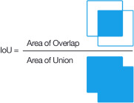
Figure 4 - Formula illustrating the intersecting reason for the integrity union [2]
Mean Average Precision (mAP) is another core metric, especially relevant for evaluating models across multiple classes and varying IoU thresholds. mAP represents the average precision across all classes and thresholds. Two main variants are used in this project:
- mAP@0.50, which evaluates precision at a fixed IoU threshold of 0.50.
- mAP@0.50:0.95, which averages the precision over IoU thresholds from 0.50 to 0.95 in steps of 0.05, offering a more stringent and informative assessment of the model's performance [2].

In addition to IoU and mAP, the following per-class performance metrics were also used:
- Precision, which quantifies the proportion of accurate positive detections among all predicted positives. A high precision indicates that the model is correct when it does make a detection.
- Recall, which measures the proportion of actual objects that were correctly detected by the model. High recall suggests good coverage of relevant instances in the image.
- F1-score, the harmonic mean between precision and recall, was used in model comparison (e.g., between YOLOv11 and Faster R-CNN) to capture the trade-off between these two metrics, particularly in scenarios with class imbalance or varied object sizes.

Finally, during the training phase, **loss functions** were monitored to evaluate the model’s learning dynamics. These include:
- Box Loss, which measures the localisation error between predicted and actual bounding boxes.
- Classification Loss, which quantifies the error in class label predictions.
- Distribution Focal Loss (DFL), used in the YOLOv11 architecture, enhances the precision of bounding box regression by modelling the uncertainty of continuous distributions.

Mean Average Precision (mAP), as illustrated in Figure 4, is another key metric that evaluates the model’s precision across multiple classes and IoU thresholds. Precision measures the proportion of accurate positive detections relative to the total number of predictions, while recall assesses the proportion of true positives identified from all actual objects. mAP combines these metrics to comprehensively evaluate the model’s performance across different detection scenarios [2].

Literature Review
The automated detection of graphical user interface (GUI) elements is an increasingly important area within the field of computer vision. This ability is vital for various applications, including test automation, improving accessibility, and interface design. This review thoroughly explores the use of deep learning techniques in analysing GUIs, focusing on their impact on detection accuracy and operational efficiency. Additionally, it covers recent developments, highlights current limitations, and suggests future research directions.
The review uses critical questions to evaluate the role of deep learning in GUI analysis. This systematic method aims to promote a thorough understanding of the topic and support the development of well-informed viewpoints. The chapter also outlines the data sources, key terms, keywords, and eligibility criteria used in the study. Finally, it explains the data collection process and provides answers to the research questions based on the collected data.

Research Questions
As outlined in Chapter 1.3, the primary research questions of this project are:
- RQ1: How accurately can deep learning models detect GUI elements across diverse platforms and layouts?
- RQ2: What are the limitations and scalability challenges of applying deep learning models to large-scale GUI datasets, and how can they be addressed?
- RQ3: How can deep learning models such as YOLO and Faster R-CNN be effectively implemented and trained for the specific task of GUI element detection using real annotated datasets?

Data Sources
The data sources used for this document include:
Table 1 – Data Sources
Identifier | Database | URL
DS1 | IEEE Xplore | https://ieeexplore.ieee.org/Xplore/home.jsp
DS2 | ACM Digital Library | https://dl.acm.org
DS3 | ArXiv | https://arxiv.org
DS4 | ResearchGate | https://www.researchgate.net

These platforms provide access to articles, publications, and peer-reviewed studies essential to addressing the research questions.

Search Terms
The search terms used include:

- GUI Element Detection
- Faster R-CNN
- YOLO
- Image Segmentation
- Object Detection
- Deep Learning
- Machine Learning

The research utilised combinations of these terms to ensure the inclusion of relevant studies.

Inclusion and Exclusion Criteria
Inclusion Criteria:
- IC1: Studies using deep learning models for object detection in images or interfaces.
- IC2: Research evaluating performance metrics applied to GUIs.
- IC3: Studies proposing hybrid methods to improve object detection.

Exclusion Criteria:
- EC1: Papers focusing exclusively on deep learning applications unrelated to GUIs.
- EC2: Studies that do not present quantitative performance evaluation metrics.

Discussion
Although deep learning models like Faster R-CNN and YOLO have shown impressive results in general object detection tasks, their specific use for GUI element detection remains relatively unexplored. Much of modern object detection overlooks challenges in GUIs such as overlaps, crowded layouts, and complex hierarchies, emphasising the need for methods that combine traditional image processing with deep learning.
As GUI applications become increasingly important, precisely recognising interface components is essential. Therefore, software engineering and HCI are expected to focus on advanced GUI detection models for automated testing and interface development.

RQ1: How accurately can deep learning models detect GUI elements across diverse platforms and layouts?
The rise of deep learning has led to significant progress in detecting graphical user interface (GUI) elements across various platforms. This progress is significant for automated testing and user interface (UI) design. However, the success of these models depends on architecture choices, the complexity of the GUI, and the presence of overlapping or nested components. Faster R-CNN, You Only Look Once (YOLO), and CenterNet are among the most thoroughly tested models for GUI detection. The Faster R-CNN model is acknowledged for its precision and capability to localise smaller and more intricate GUI components, particularly in densely populated interfaces. Leveraging a Region Proposal Network (RPN), Faster R-CNN excels in detecting overlapping elements, a common challenge in GUI layouts. This model consistently achieves superior results in non-text element detection, as highlighted in performance comparisons where Faster R-CNN achieved an F1-score of 0.438, outperforming YOLOv3 (0.383) and CenterNet (0.401) [1]. These results underscore the strength of region-based architectures in scenarios demanding detailed analysis and high localisation accuracy, as shown in Figure 6.
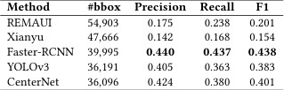
Figure 6 - Performance non-text elements detection (IoU > 0.9) [1]
Despite Faster R-CNN's precision advantages, YOLO models have gained popularity for their real-time processing capabilities. YOLO’s single-shot detection mechanism allows it to rapidly analyse GUI layouts, making it highly suitable for mobile and web application testing. However, earlier versions of YOLO encountered difficulties in detecting smaller or densely packed GUI components due to limitations inherent in their grid-based detection architecture.
This deficit frequently failed to detect intricate interfaces, a challenge that became especially apparent in the context of non-text graphical user interface element detection tasks. Still, YOLOv3 demonstrated competitive performance, consistently outperforming traditional methods like REMAUI and Xianyu across various IoU thresholds. As illustrated in Figure 7, YOLOv3’s F1-score of 0.383, while lower than Faster R-CNN, remains significantly higher than conventional GUI detection tools [1].
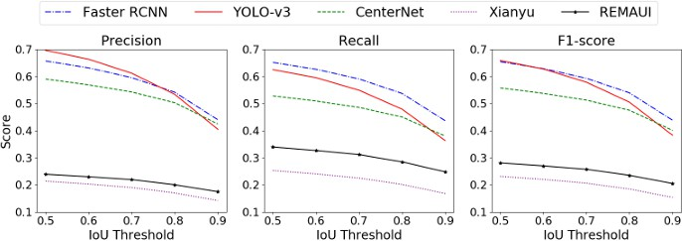
Figure 7 - Performance at different IoU thresholds [1]
CenterNet emerges as a middle ground model, balancing accuracy and speed by employing keypoint-based object detection. This approach predicts the center points of GUI components to generate bounding boxes efficiently. CenterNet often surpasses YOLOv3 in terms of recall, but overall performance falls slightly behind Faster R-CNN, with an F1-score of 0.401 in non-text detection tasks [1]. While not as precise as region-based architectures, its ability to manage overlapping GUI components provides a reliable option when speed is essential.
A hybrid approach that integrates traditional image processing techniques with deep learning models has proven to be an effective solution for overcoming the limitations of standalone models. Combining methods such as edge detection and segmentation with convolutional neural networks (CNNs), hybrid models achieve state-of-the-art performance in GUI detection.
This is evident in Figure 8, where the hybrid model presented in the study achieves an F1-score of 0.524 for overall GUI detection and 0.449 for non-text elements, outperforming Faster R-CNN, YOLOv3, and CenterNet. These results highlight the potential of hybrid models to enhance detection accuracy, particularly in complex GUI environments with overlapping and nested elements.
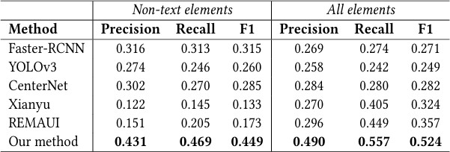
Figure 8 - Overall results of object detection (IoU>0.9) [1]
The progression of YOLO models has led to the creation of YOLOv10, which incorporates architectural improvements that address the limitations of earlier versions. In a study, YOLOv10 is recognised as a milestone in GUI detection, aiming to improve accuracy and efficiency in dense and overlapping GUI environments [20]. A significant innovation in YOLOv10 is the adoption of a dual-assignment strategy for NMS-free (Non-Maximum Suppression) training, allowing faster inference without sacrificing accuracy. This new architecture incorporates lighter classification heads and spatial-channel decoupled downsampling, optimising the model’s ability to process complex GUI layouts with reduced computational overhead.
Figure 9 depicts the performance comparison between YOLOv10 and previous versions (YOLOv6, YOLOv7, YOLOv8, and YOLOv9) and other state-of-the-art models like RT-DETR. The analysis reveals that YOLOv10 consistently outperforms its predecessors, maintaining high accuracy (mAP) while achieving lower latency, making it an asset for GUI detection tasks that require fast response times. Additionally, YOLOv10 achieves higher accuracy with fewer parameters, underscoring its efficiency and suitability for environments with computational constraints.
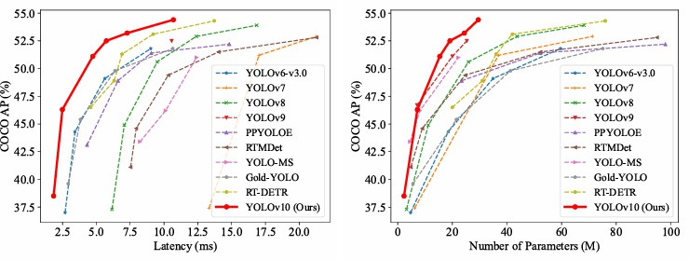
Figure 9 - - Models Performance Comparison [20]

Figure 10 visualises the object detection pipeline employed by YOLO models. This diagram outlines the entire detection process used in YOLOv4, highlighting the essential stages from input processing to dense and sparse prediction layers. It provides insight into how YOLO achieves efficient object detection by refining predictions at multiple stages. This structured process is pivotal in enhancing GUI detection, reinforcing the relevance of YOLO’s architectural improvements for real-time applications.
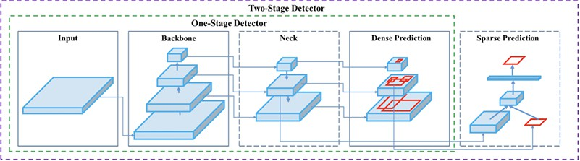
Figure 10 - Object Detection Pipeline in YOLOv4
The study results indicate that YOLOv10-S operates 1.8 times faster than RT-DETR-R18 while maintaining comparable accuracy levels. Moreover, YOLOv10-B reduces latency by 46% compared to YOLOv9-C, solidifying YOLOv10 as a robust and adaptable solution for real-time GUI detection scenarios [20].
The comprehensive analysis covering Faster R-CNN, YOLO models, and hybrid approaches collectively reflects the changing landscape of GUI detection technologies. Faster R-CNN excels in high-precision tasks like detecting small GUI elements in complex layouts. Conversely, YOLO models are favoured for real-time detection, allowing swift processing in busy environments.
The hybrid model surpasses standalone YOLO and Faster R-CNN, as demonstrated by data. Combining image processing with deep learning improves GUI detection, enabling researchers and developers to tackle challenges more effectively through increased accuracy, scalability, and real-time performance.
Although YOLOv11 advances GUI element detection, Faster R-CNN remains essential for accuracy localisation. In addition, the demonstrated efficacy of integrating hybrid models actively reinforces the substantial potential for future advancements, ensuring the continuous improvement of methods within the domain of GUI detection technologies.

RQ2: What are the limitations and scalability challenges of applying deep learning models to large-scale GUI datasets, and how can they be addressed?
The application of deep learning models to large-scale Graphical User Interface (GUI) datasets presents considerable scalability and performance challenges, as extensively detailed in seminal works [25][26]. One of the foremost impediments to advancement in this domain stems from the substantial computational complexity intrinsically required to train models comprising millions of parameters. Convolutional Neural Networks (CNNs) and transformer architectures require significant processing power, which consequently results in extended training durations when applied to large GUI datasets. This inherent limitation possesses the potential to impede the expeditious iteration and refinement critical for effective research processes, especially for smaller research teams or organisations operating with constrained computational resources [25].
Figure 11 (Parameter Server Architecture) visually demonstrates the distributed nature of model training using parameter servers. This system partitions parameters across multiple servers, allowing workers to push and pull model updates asynchronously, enhancing scalability and mitigating the risk of bottlenecks. This architecture reduces the load on individual machines by distributing resource allocation throughout the distributed environment, which is essential for managing large-scale GUI datasets.
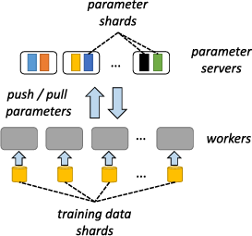
Figure 11 - Parameter Server Architecture [25]
Memory constraints further exacerbate scalability issues. GUI datasets, often comprising high-resolution screenshots, annotated metadata, and extracted features, place significant demands on storage and RAM capacity. Training models on such datasets usually results in out-of-memory errors, particularly when large mini-batches are used to accelerate convergence. These challenges become even more pronounced with GUI layouts featuring densely packed or overlapping elements, which require higher-resolution inputs and more complex feature extraction techniques to maintain detection accuracy [25].
Figure 12 depicts a distributed architecture, such as AllReduce, which plays a critical role in addressing memory limitations by synchronising gradients across nodes during model training. AllReduce improves the efficiency of distributed learning by reducing communication overhead through merging gradients from multiple workers. This method ensures faster convergence and minimises unnecessary data transfers, allowing deep learning models to scale across large datasets while avoiding memory bottlenecks.
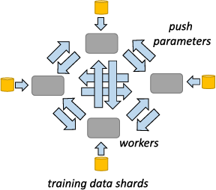
Figure 12 - AllReduce Architecture [25]

Another significant limitation is the input/output (I/O) bottleneck related to loading and preprocessing large datasets. As pointed out by Mayer and Jacobsen, training pipelines experience latency caused by data transfer inefficiencies, especially in distributed environments where datasets are spread across multiple nodes. These I/O bottlenecks have been shown to reduce the efficiency of distributed learning frameworks, because they slow down training and create difficulties with synchronisation. The communication overhead involved in synchronising gradient updates across devices has been shown to result in diminishing returns, thereby limiting overall scalability.
Figure 13 further illustrates distributed processing systems, which are essential for addressing these scalability challenges [26]. The following elements are to be considered:
- The MapReduce system processes large datasets by dividing tasks into smaller parallel jobs.
- Graph-parallel systems, which optimise the processing of graph-structured data.
- Parameter-Server clusters that distribute model parameters across servers.
- The AllReduce communication method minimises latency by aggregating gradients efficiently.
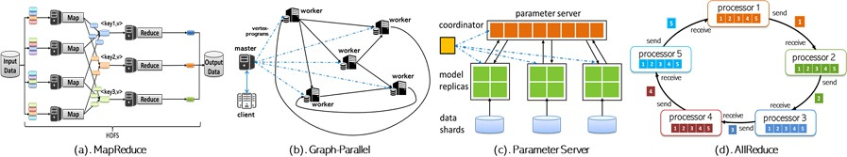
Figure 13 - Illustration of distributed deep learning training, showing model splitting, batch data input, parallel processing, and parameter synchronisation. [26]

These distributed architectures form the foundation of scalable deep learning systems, demonstrating that the interplay between model partitioning, data sharding, and synchronous training optimisation strategies has been proposed to address these issues, thereby enhancing model architecture and training processes. A notable technique in this area is model simplification through methods such as knowledge distillation and pruning. Knowledge distillation enables smaller models to learn from larger ones. Pruning improves this by removing unnecessary parameters to boost speed and reduce memory, maintaining accuracy. Quantisation further enhances performance with lower-precision weights, reducing memory use and increasing speed.
Training efficacy can also be substantially increased via data parallelism (processing multiple datasets concurrently across GPUs) or model parallelism (distributing model components across devices). As illustrated in Figure 14, the distributed training process involves dividing and distributing the deep learning model to workers, with batches of data being processed concurrently. This system ensures that model parameters are synchronised after each training iteration, facilitating efficient large-scale model training.
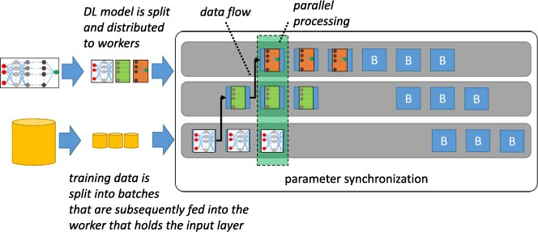
Figure 14 - Illustration of distributed deep learning training, showing model splitting, batch data input, parallel processing, and parameter synchronisation. [25]
Data management strategies, such as pre-fetching, compressing datasets during storage, and decompressing them at runtime, significantly reduce I/O bottlenecks. Additionally, dataset partitioning—dividing data into smaller, concurrently processed parts—enhances throughput and accelerates model training [25].
The efficacy of transfer learning as a technique for improving scalability is extensively documented. By strategically leveraging pre-trained models and subsequently fine-tuning them on smaller, domain-specific GUI datasets, researchers can circumvent the arduous imperative for extensive training on massive-scale datasets. This method reduces computational demands and speeds up deployment by efficiently leveraging existing knowledge, allowing models to adapt quickly to new environments with minimal retraining [25].

Using cloud-based distributed computing services like AWS and Google Cloud addresses scalability issues by offering access to flexible GPU clusters. These platforms enable developers to modify infrastructure dynamically based on model complexity and dataset size, encouraging broader use of deep learning techniques for GUI detection. Moreover, model ensembling, where multiple models are combined to improve accuracy, distributes computational workload across various architectures, boosting scalability without significantly increasing resource demands [25].
Scaling deep learning models for GUI detection presents significant hurdles. The effective combination of model simplification, distributed computing, efficient data handling and hybrid methodologies overcomes the scalability challenges associated with GUI detection. These strategies guarantee reliable model performance when working with large and varied datasets. This, in turn, supports the development of robust, scalable solutions for modern digital interfaces.

RQ3: How can deep learning models such as YOLO and Faster R-CNN be effectively implemented and trained for the specific task of GUI element detection using real annotated datasets?
The practical application and training of deep learning models such as YOLO and Faster R-CNN for GUI element detection rely on carefully adapting these models to the specific features of graphical user interfaces. Unlike traditional object detection fields, GUI components are often densely arranged, vary significantly in size, and include a range of semantically different yet visually similar elements. To address this, the Wave-UI dataset [27] was chosen, providing a diverse set of annotated interface screenshots with buttons, icons, text fields, sliders, and other common elements.
Annotation was performed manually using Label Studio, ensuring high-quality bounding boxes and consistent class labels throughout the dataset. The annotations were exported in both YOLO and COCO formats to meet the specific requirements of each model architecture. The dataset was then divided into 80% training and 20% validation sets, preserving class representation across both subsets. This organisation allowed for consistent model evaluation and comparison.
For the YOLO models, three versions—YOLOv8, YOLOv10, and YOLOv11—were trained using the Ultralytics framework in Google Colab. The training process involved resizing all images to 640×640 pixels, setting a batch size of 16, and running for 50 epochs with pre-trained weights. The configuration was specified in a data.yaml file, which was automatically generated from the class structure. Among the tested models, YOLOv11 achieved the best overall performance in terms of precision, recall, and mean average precision (mAP), particularly excelling at detecting small or overlapping elements thanks to its lightweight architecture and efficient anchor-free detection mechanism.

Similarly, Faster R-CNN was implemented using PyTorch and the torchvision.models.detection module, with a ResNet-50 backbone combined with a Feature Pyramid Network (FPN). This two-stage detector was trained on the same dataset after converting the annotations to the COCO format. Data augmentations such as horizontal flipping and colour jittering were applied to enhance generalisation. Although the training and inference times were longer, Faster R-CNN provided accurate bounding box placements and showed robustness in less cluttered GUIs.
Throughout the experimentation process, several challenges were addressed to optimise the training for GUI-specific contexts. Class imbalance was mitigated through data augmentation, while the small size of many GUI elements was handled by increasing input resolution and employing architectures with multi-scale feature extraction. The evaluation included traditional metrics such as IoU and mAP, as well as visual inspection of detection results to assess qualitative performance in complex interface layouts.
Both models are effective when correctly adapted, but they cater to different operational requirements. YOLOv11 excels in real-time scenarios and settings with limited computational power, offering an optimal balance of speed and accuracy. In contrast, Faster R-CNN may be preferable when higher precision is required, and execution time is less critical. The successful deployment of these models shows that deep learning can be a viable and scalable solution for GUI element detection, provided that data preparation, annotation, and model selection are carefully aligned with the specific needs of the interface domain.

Implementation
This chapter provides a comprehensive account of the steps followed during the development and training of various models, including YOLO, Faster R-CNN, and a model proposed for the detection of graphic elements (GUI). The implementation was conducted on Google Colab, utilising the freely available computing resources (GPU).

Dataset Preparation

Source and Characteristics of the Dataset
The Wave-UI dataset [27] was used to train and evaluate the models developed in this work. This dataset consists of images containing user interface (UI) elements such as buttons, icons, and text fields. The dataset provides a diverse range of graphical components typically found in web and application interfaces from different platforms, such as mobile and pc, which makes it suitable for training deep learning models aimed at GUI detection tasks.

Annotation Process with Label Studio
To annotate the dataset, the open-source platform Label Studio was used. Each image was manually labelled using bounding boxes corresponding to 16 predefined GUI component classes, as shown in the Table 2:

Table 2 – GUI Component Classes
Component | Description | Representation
Button | A clickable element that triggers an action when pressed. | 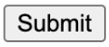
Checkbox | A toggle option that can be either selected or deselected.
Dropdown | A collapsible list that allows selection from multiple options. | 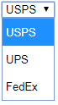
Icon | Small graphical symbol representing a function or object.
Image | Visual media element used for decoration or information. | 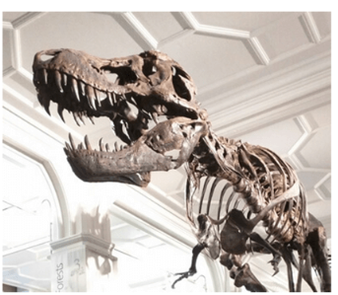
Input | A field where users can type data or text. | 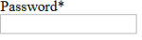
Link | Clickable text or element that navigates to another page or section.
Menu | List of options or commands grouped. | 
Modal | A pop-up window that requires interaction before proceeding. | 
Progress bar | Visual indicator of task completion or progress.
Radio button | An option selector that allows only one selection within a group. | 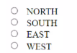
Slider | Interactive bar for selecting a value within a range. | 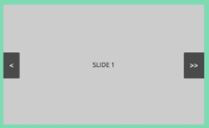
Tab | A navigation element that switches between different views or panels. | 
Text | Static display of written content or labels.
Text field | Input area for entering single or multiline text. | 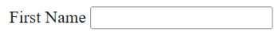
Toolbar | Row of icons or buttons grouped for quick access to functions. | 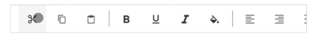

All images in the dataset were manually annotated using Label Studio, an open-source annotation platform. Each graphical element—such as buttons, icons, checkboxes, or input fields—was enclosed in a bounding box and assigned a class label from a predefined list of 16 categories.
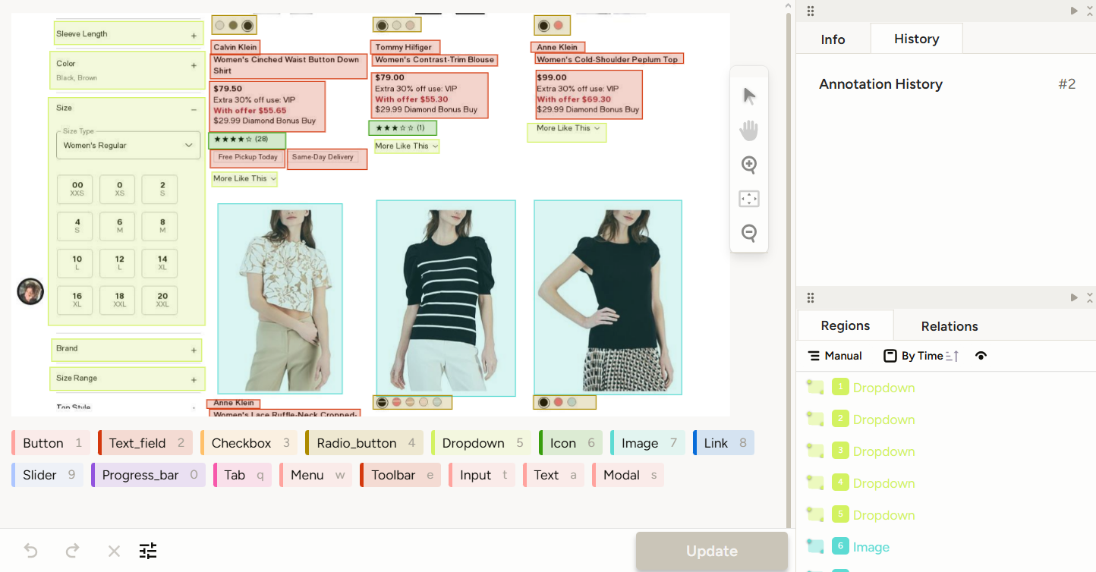
Figure 15 – Process of Labelling Images
The Label Studio interface (see Figure 15) facilitates this process by displaying the available label categories at the bottom of the screen. When annotating an image, GUI elements are marked with coloured bounding boxes, where each colour corresponds to a specific class. The right panel provides a summary of annotation history and a list of detected elements, helping to ensure completeness and consistency throughout the process.
Once annotated, the data was exported in YOLO format, producing one .txt file per image. Each line of this file follows the structure of the Figure 16.
Figure 16 – Structure YOLO Annotation
This format uses normalised coordinates and represents each object with a single line (see Figure 17).
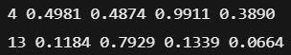
Figure 17 – Example of YOLO Annotation
These values indicate, respectively, the class ID, the centre coordinates (x, y), and the size (width, height) of each bounding box, all relative to the image size.
In addition to YOLO, the annotations were also exported in COCO format, which was required for training Faster R-CNN. Label Studio supports this export natively. Both formats ensured seamless integration with the training pipelines developed in this project.
To streamline the training and validation process, all annotated images and labels were systematically organised into two folders: train and val.

The annotations were exported in two formats: YOLO and COCO. The YOLO format generates a `.txt` file per image with normalised bounding box coordinates and class identifiers. The COCO format creates a structured JSON file containing metadata, categories, and annotation fields required for training with frameworks like PyTorch.

Dataset Organisation and Splitting
After annotation, the dataset was randomly divided into three subsets:
- 70% for training
- 20% for testing
- 10% for validation
The dataset was split in a way that ensured representation of all 16 classes in both subsets. Images and labels were stored in structured directories to support automated loading during model training.

YOLO Implementation
In this project, a comparative approach was adopted to evaluate the effectiveness of YOLOv11, YOLOv10, and YOLOv8 models in detecting GUI elements. This exploration aimed to evaluate each model's performance, accuracy, and efficiency to facilitate the selection of the most suitable architecture for the specific task of GUI element detection.
YOLOv8 was chosen due to its widespread use in the literature and proven track record of delivering consistent results across various object detection tasks, including structured environments. It served as a reliable baseline for comparison. Conversely, YOLOv10 and YOLOv11 were selected as they represent the most recent developments in the YOLO model family at the time of experimentation. By including both an established and two cutting-edge models, the evaluation aimed to balance empirical robustness with state-of-the-art innovation.

Development Environment Setup
The development environment chosen for this implementation was Google Colab. This platform provides convenient access to free GPU resources, which significantly expedites the computationally intensive training process of deep learning models.
The primary tools and libraries employed for the entire implementation are listed below:
- Python: The foundational programming language used for all scripting, model interaction, and data manipulation.
- PyTorch: The open-source machine learning framework that serves as the core backend for the YOLO models, enabling efficient tensor computations and neural network operations.
- YOLO (You Only Look Once): A state-of-the-art object detection model known for its speed and accuracy, based on convolutional neural networks (CNNs).

Dataset Preparation and data.yaml
A crucial step in preparing the dataset for YOLO model training is the creation of the data.yaml configuration file. This file, Snippet 1, acts as a manifest for the YOLO framework, informing it about the dataset's structure, the location of training and validation images, and the names and total count of the classes to be detected.
A helper Python script was developed to generate this file automatically based on the dataset’s structure and label information.
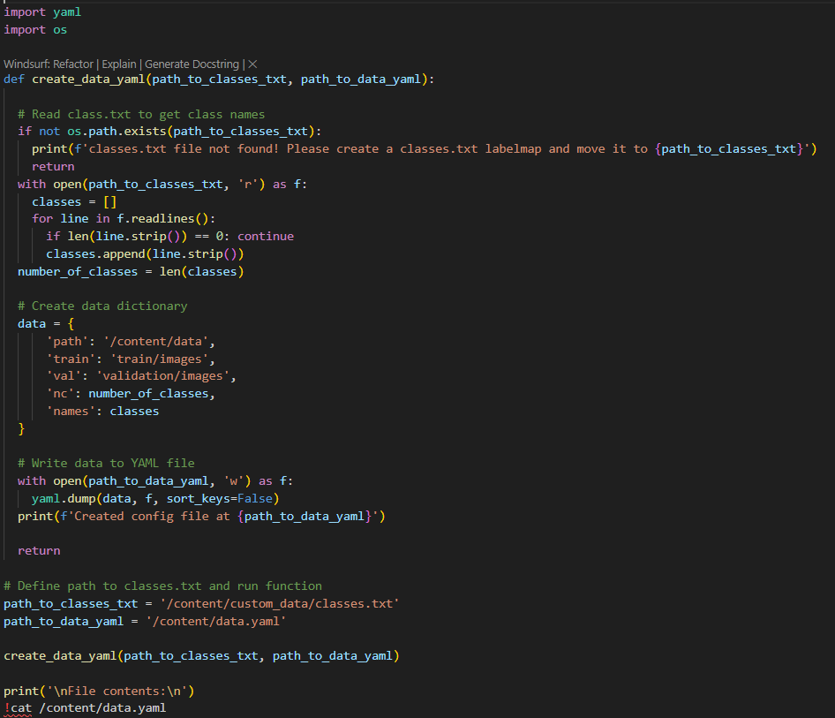
Snippet 1 – Create data.yaml
After preparing the images and their corresponding annotation files (containing class labels and bounding box coordinates in YOLO format), a dedicated Python script, image X, was utilised to automate the generation of this essential data.yaml file. The functionality of this script is detailed as follows:
- Class File Verification: Initially, the script verifies the existence of a classes.txt file. This file is expected to contain a newline-separated list of all class names that the YOLO model will learn to identify (e.g., 'Button', 'Checkbox', 'Dropdown', etc.). If classes.txt is not found at the specified path, an error message is displayed, prompting the user to create the required file.
- Dynamic Class Extraction: Upon successful verification, the script reads the contents of classes.txt, parsing each line to extract individual class names. These names are then stored in a Python list, and the total number of classes (nc) is dynamically determined based on the length of this list.
- YAML Dictionary Construction: This collected information is then structured into a Python dictionary, which forms the basis for the data.yaml content. The dictionary includes the following key parameters:
  - path: Specifies the root directory of the dataset, where the train and val folders reside.
  - train: Points to the subdirectory containing the training images.
  - val: Points to the subdirectory containing validation images.
  - nc: Represents the total number of detected classes, dynamically calculated.
  - names: Lists the names of the detected classes, previously read from classes.txt.
- YAML File Export: Finally, this dictionary is exported as a YAML file named data.yaml using Python's PyYAML library (or similar built-in functionality if a custom YAML writer is used). The generated data.yaml file provides the YOLO model with all the necessary configurations to correctly load and interpret the dataset, classes, and annotations during the training process, thereby significantly streamlining model development and ensuring reproducibility.

Training Process
The YOLO models (YOLOv11, YOLOv10, and YOLOv8, as applicable) were trained using the training script provided in their respective official repositories. The training process was initiated with a carefully selected set of parameters to optimise performance and convergence, described in Snippet 2. These parameters, configured for each training run, included:
Snippet 2 - Command to create YOLO model

- img 640: This parameter specifies that input images are resized to a resolution of 640x640 pixels before being fed into the network. This standardisation helps maintain consistency in feature extraction and optimises computational efficiency during training.
- batch 16: Defines the batch size, meaning 16 images were processed simultaneously in each training iteration. A suitable batch size balances computational load with effective gradient updates.
- epochs 50: Represents the total number of complete passes through the entire training dataset. Fifty epochs were deemed sufficient for the models to learn robust features and minimise loss, while also managing training time.
- weights: The models were initialised with pre-trained weights. Utilising pre-trained weights on a large dataset like ImageNet allows the models to start with a strong foundation of learned features, significantly speeding up convergence and improving performance on the new GUI detection task.
- cache: This parameter enables temporary storage of image data in memory (RAM) or on disk. Caching optimises the data loading process, especially for datasets that fit into memory, by reducing I/O operations and thus accelerating training speed, particularly during subsequent epochs.
After initiation, the training algorithm systematically ingests images residing within the designated training and validation directories to commence model parameter optimisation. After each training epoch, the model's performance is rigorously evaluated against the validation dataset. Key metrics such as mean average precision (mAP), precision and recall are carefully documented. A consistent increase in mAP across epochs is the main sign of practical training. The training process concludes upon reaching the total number of epochs predetermined by the user.
The optimal model weights, representing the best performance achieved during training, are saved as best.pt. Furthermore, the /train folder contains additional insights into the training process, including a results.png file that visually depicts the progression of loss, precision, recall, and mAP across all epochs.

Inference on Unseen Images
To rigorously validate the trained models' practical utility and generalisation capabilities, a dedicated inference and testing phase was conducted. This involved applying the best.pt model (derived from the training process) to a distinct set of unseen GUI images—images that were not included in either the training or validation splits of the original dataset. This approach is crucial for assessing how well the model performs on new, real-world data.
Inference was performed by executing the following YOLO detection command.
Snippet 3 – Command to use the model in an image
This command directs the detect.py script to:
- weights /best.pt: Load the most performant model weights obtained from the training phase.
- img 640: Resize all input images to a resolution of 640x640 pixels before inference, ensuring consistency with the training data's input dimensions.
- conf 0.25: Set a confidence threshold of 0.25. This means that only detections with a prediction confidence score of 25% or higher will be displayed and considered valid. This parameter allows for filtering out low-confidence predictions.
- Source /images_teste: Specify the directory containing the new, unseen GUI images on which the inference is to be performed.
The visual outcomes of this inference process demonstrated the model's robust capacity to efficiently and accurately discern various graphic components across diverse user interfaces. The generated bounding box predictions, alongside their corresponding class labels and confidence scores, effectively substantiated the efficacy and practical relevance of the trained object detection model for identifying GUI elements in novel contexts.

Comparison Between YOLOv8, YOLOv10, and YOLOv11
A detailed comparative evaluation was performed among the YOLOv11, YOLOv10, and YOLOv8 models to ascertain their respective strengths and weaknesses in detecting GUI elements. This assessment was based on extensive training sessions, each spanning 60 epochs and utilising a dataset comprising 500 images. The performance of each model was meticulously assessed using a standard set of key object detection metrics: precision, recall, and two variations of mean Average Precision (mAP)—specifically, mAP@0.50 (which measures performance at an Intersection over Union (IoU) threshold of 0.50) and mAP@0.50:0.95 (representing the average mAP across IoU thresholds from 0.50 to 0.95, in steps of 0.05). Furthermore, the associated loss metrics—namely Box Loss (quantifying the accuracy of bounding box predictions), Classification Loss (measuring the accuracy of class predictions), and Distribution Focal Loss (DFL) (a more advanced loss function for bounding box regression)—were also closely monitored.
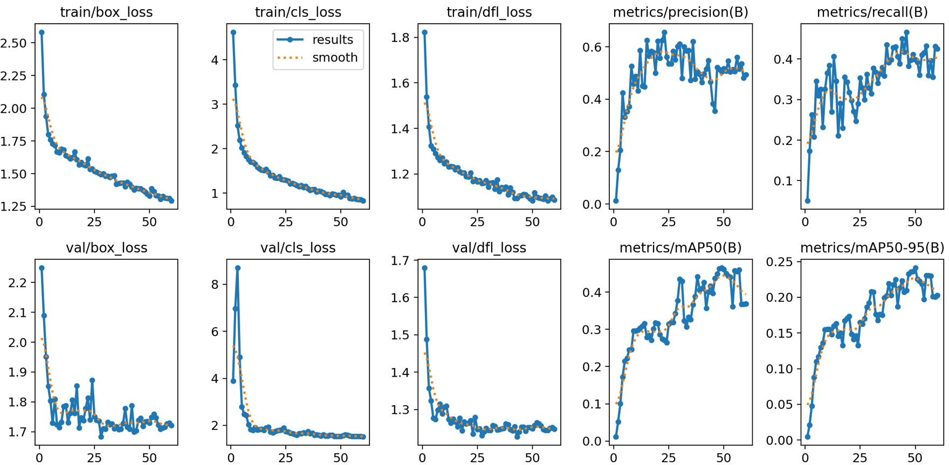
Figure 18 - YOLO model results template
All trained models automatically generated comprehensive performance reports and visualisations, crucial for understanding their learning dynamics. An example of such a report is presented in Figure 18, which showcases a series of graphs illustrating the evolution of various metrics throughout the training and validation phases.
YOLOv11 Performance Analysis
The YOLOv11 model demonstrated the strongest overall performance among all evaluated versions for GUI element detection. After completing 60 training epochs, the YOLOv11 model achieved the following remarkable performance metrics on the validation dataset:
- Precision: 49.41%
- Recall: 42.58%
- mAP@0.50: 46.04%
- mAP@0.50:0.95: 24.12%

These results highlight YOLOv11's strong capability in accurately identifying GUI components while minimising false positives and false negatives.

Figure 19 - YOLOv11 model results
The training progression and performance evolution of the YOLOv11 model are comprehensively illustrated in Figure 19. This figure provides detailed visual insights into how various metrics evolved across the 60 epochs:
- Loss Metrics: Throughout training, YOLOv11 exhibited stable convergence, characterised by a significant and consistent decrease in all three primary loss components. Specifically, the box loss (which quantifies bounding box localisation error) reduced significantly from approximately 2.58 at epoch 1 down to around 1.29 by epoch 60. Similarly, the classification loss (measuring the accuracy of class predictions) dropped from 4.62 to a low of approximately 0.83, and the DFL loss (related to bounding box regression quality) decreased from 1.82 to approximately 1.08. The steady decline in both training and validation losses, as depicted in the upper and lower rows of Figure 1.2, respectively, indicates effective learning without significant signs of overfitting.
- Performance Metrics: Concurrently, the model showcased a steady and consistent improvement in its primary performance metrics. As seen in Figure 1.2, both precision and recall evolved positively and generally stabilised towards the latter half of the training, demonstrating a balanced ability to accurately identify GUI elements while minimising both false positives and false negatives. The mAP@0.50 and mAP@0.50:0.95 also showed clear upward trends, signifying an increasing overall detection accuracy and robustness across different Intersection over Union (IoU) thresholds.
The combination of these consistently decreasing loss values and steadily improving performance metrics confirms YOLOv11's efficient learning process, stable convergence, and strong generalisation capabilities on the unseen validation data. This holistic view, supported by the graphical representation, underscores YOLOv11 as a highly effective architecture for the task of GUI element detection.
YOLOv10 Performance Analysis
The YOLOv10 model demonstrated moderate performance in detecting GUI elements. While it showed improvements throughout its training, its results at epoch 60 were notably lower compared to both YOLOv11 and YOLOv8, indicating that it did not achieve the same level of efficacy for this specific task. At the culmination of the training process, YOLOv10 achieved the following key performance metrics on the validation dataset:

- Precision: 37.93%
- Recall: 34.89%
- mAP@0.50: 33.31%
- mAP@0.50:0.95: 17.64%

These figures suggest that YOLOv10, despite its advancements, struggled to match the higher accuracy and recall rates observed in the other models.
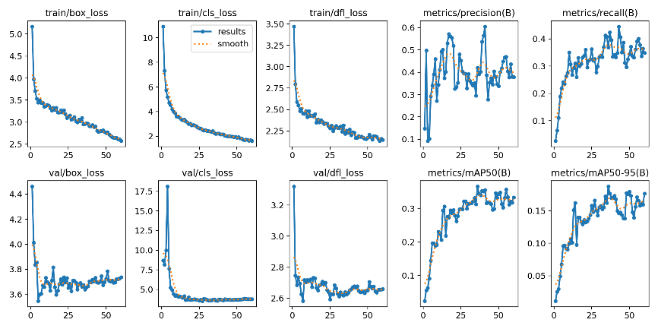
Figure 20 – YOLOv10 model results
The detailed training progression and performance metrics for the YOLOv10 model are visually presented in Figure 20. This series of graphs provides crucial insights into the model's learning behaviour across the 60 epochs:
- Loss Metrics: YOLOv10 exhibited progressive reductions in its training loss components. Specifically, the box loss decreased from approximately 5.17 at epoch 1 to around 2.57 by epoch 60. Similarly, the classification loss saw a reduction from an initial value of 10.90 down to approximately 1.61, and the DFL loss decreased from 3.47 to roughly 2.14. While these reductions demonstrate successful learning, the validation losses, especially val/box_loss, exhibit a less stable trend, indicating potential plateaus or minor fluctuations in performance after initial improvements, as shown in the lower row of Figure 1.3.
- Performance Metrics: Despite the loss reduction, the improvement in key performance metrics for YOLOv10 was less pronounced compared to YOLOv11. As shown in Figure 1.3, both precision and recall reached their peak values relatively early in training but then exhibited more variability and a lower ceiling. The mAP@0.50 and mAP@0.50:0.95 also showed a less steep ascent and lower overall values, failing to reach the higher benchmarks set by YOLOv11.
YOLOv10 encountered challenges, particularly reflected in its lower recall values. This indicates that the model had difficulties consistently identifying all relevant GUI elements within images, especially when dealing with smaller or densely arranged components. Although it demonstrated learning capability through loss reduction, these improvements were not sufficient to achieve competitive detection performance when compared to the superior results obtained by YOLOv11 and YOLOv8 in this specific application.
YOLOv8 Performance Analysis
The YOLOv8 model provided a balanced and robust performance in GUI element detection, demonstrating a clear superiority over YOLOv10 but slightly trailing YOLOv11 in overall effectiveness. At the culmination of 60 training epochs, YOLOv8 attained the following performance metrics on the validation dataset:
- Precision: 53.61%
- Recall: 47.95%
- mAP@0.50: 40.78%
- mAP@0.50:0.95: 22.82%

These results indicate YOLOv8's strong capability in accurate identification, especially its high precision, suggesting a low rate of false positive detections.
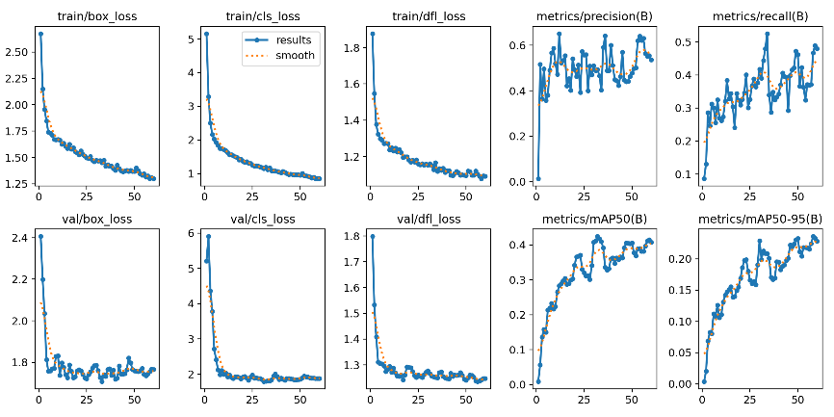
Figure 21 - YOLOv8 model results
The training progression and performance evolution of the YOLOv8 model are clearly illustrated in Figure 21. This figure provides visual evidence of the model's learning dynamics across the 60 epochs:

- Loss Metrics: YOLOv8 exhibited rapid convergence in the early epochs, followed by steady reductions in its loss components throughout the training session. The box loss (localisation error) decreased significantly from approximately 2.67 at epoch 1 to about 1.29 by epoch 60. Similarly, the classification loss (class prediction error) dropped from 5.15 to around 0.85, and the DFL loss (bounding box regression quality) reduced from 1.87 to approximately 1.09. As depicted in the upper and lower rows of Figure 1.4, both training and validation losses show stable downward trends, confirming efficient learning and a well-generalised model.
- Performance Metrics: Concurrently, YOLOv8 demonstrated consistent improvements in its primary performance metrics. The graphs in Figure 1.4 show that precision rapidly increased in early epochs and then remained consistently high, indicating excellent accuracy in identifications. While recall also improved steadily, it did not reach the same peak levels as precision, suggesting that YOLOv8 might occasionally miss some true positive GUI elements, particularly those that are small, occluded, or complex. The mAP@0.50 and mAP@0.50:0.95 metrics also displayed strong upward trends, reflecting overall improved detection capabilities, though with slightly lower values compared to YOLOv11.

Considering all the results, below is a preview of the results
Table 3 – Comparison of Results between YOLO Models
Model | Precision | Recall | mAP@0.50 | mAP@0.50:0.95
YOLOv8 | 53.61% | 47.95% | 40.78% | 22.82%
YOLOv10 | 37.93% | 34.89% | 33.31% | 17.64%
YOLOv11 | 49.41% | 42.58% | 46.04% | 24.12%

YOLOv11 demonstrated superior balance between detection accuracy and generalisation, particularly for small and densely packed elements.

Challenges and Optimisations
During the implementation and training phases of this project, several significant challenges were observed, which afforded invaluable learning opportunities and informed subsequent optimisation strategies:
Dataset Imbalance and Representation:
- Challenge: The initial challenge pertained to ensuring a balanced and adequate representation of all defined GUI element classes within the dataset. Some classes are naturally less frequent in real-world GUIs, which can lead to models learning biased representations and performing poorly on underrepresented classes.

- Optimisation Strategy: While not explicitly detailed, strategies typically involve data augmentation (e.g., rotation, scaling, brightness adjustments) tailored explicitly to underrepresented classes, or sampling techniques (e.g., oversampling minority classes, undersampling majority classes) during data loading. Careful monitoring of per-class performance during validation was crucial to identify and address such imbalances.
Hyperparameter Optimisation:
- Challenge: The second critical issue revolved around the meticulous optimisation of hyperparameters, including the learning rate, number of epochs, and batch size. The selection of suboptimal values for these parameters has been shown to have a detrimental effect on model performance, resulting in slow convergence, underfitting or overfitting.
- Optimisation Strategy: An iterative approach was employed, involving systematic experimentation with different combinations of these parameters. This frequently encompasses techniques such as grid search, random search, or more advanced methods, including Bayesian optimisation, in conjunction with meticulous monitoring of validation loss and mAP metrics, to ascertain the optimal configuration that guarantees robust learning and generalisation.
Management of computational resources:
- Challenge: Effective management of computational resources, which are predominantly constrained by the Google Colab environment, was identified as a recurring challenge. Deep learning models require substantial GPU memory and processing power for training, which can result in system instability or extended training times.
- Optimisation Strategy: We implemented several strategies to manage computational resources effectively. We achieved optimisation by selecting iteration sizes for GPU memory, improving data loading to lessen CPU bottlenecks, and utilising Google Colab's higher-tier GPUs. Efficient coding and early stopping were also vital for maximising our resources and avoiding unnecessary computation.
It is essential to resolve these issues properly to attain the strong performance shown by the selected YOLOv11 model.

Faster R-CNN Implementation
Although YOLO models are renowned for their speed and efficiency, two-stage object detection architectures such as Fast R-CNN offer an alternative approach that can provide greater precision in certain situations, particularly when localisation accuracy is critical. In this section, we explore the implementation and performance of the Fast R-CNN model for the task of Graphical User Interface (GUI) element detection.

Fast R-CNN is a state-of-the-art object detection algorithm known for its precision and training efficiency compared to its predecessors (R-CNN and SPP-net). It enhances the detection process by utilising a Convolutional Neural Network (CNN) to extract features from the entire input image only once, instead of processing each proposed region individually. Key features of Fast R-CNN include:
- Region Proposals: Initially, an algorithm like Selective Search or EdgeBoxes is used to generate a set of Regions of Interest (RoIs) within the image, which are potential object locations.
- RoI Pooling Layer: For each RoI, the RoI Pooling layer extracts a slice from the feature map generated by the CNN and resizes it to a fixed dimension. This allows the same network to classify and refine bounding boxes, regardless of the original proposal size.
- Multi-Task Network: Fast R-CNN employs a multi-task network that simultaneously performs two tasks:
  - Classification: A Softmax classifier predicts the object class for each RoI.
  - Bounding Box Regression: A regressor refines the bounding box coordinates for each RoI, improving its accuracy.
- End-to-End Training: The model is trained end-to-end, simplifying the training process and enhancing its efficiency.

Environment and Tools
The development environment for the Fast R-CNN implementation matched that used for the YOLO models. Google Colab was the selected platform, offering easy access to Graphics Processing Unit (GPU) resources vital for speeding up deep learning model training. Faster R-CNN was built using PyTorch and the `torchvision.models.detection` module. Like the YOLO models, it was trained on Google Colab.olab.

Conversion to COCO Format
Dataset preparation for Fast R-CNN significantly differs from the YOLO format, as this model requires annotations in the COCO (Common Objects in Context) format. This format is widely adopted in the computer vision community. It organises annotations in a structured JSON file, which includes detailed information about images, class categories, and multiple object instances per image.
The conversion of the previously annotated dataset (whether from its original format or YOLO) to the COCO format involved creating a JSON file that maps:

- Image Information: Unique image ID, file name, width, and height.
- Categories: Unique ID for each GUI class (e.g., 1 for "Button," 2 for "Checkbox," etc.), along with category names.
- Annotations: For each object instance in an image, the JSON stores the image ID, category ID, bounding box [x_min, y_min, width, height], object area, and annotation ID.
Once the dataset was formatted to COCO, it was loaded and pre-processed using PyTorch's CocoDetection and DataLoader classes.

Architecture and Backbone
For the Fast R-CNN implementation, the Faster R-CNN architecture with a ResNet50 backbone and a Feature Pyramid Network (FPN) was utilised, as presented in Snippet 4.
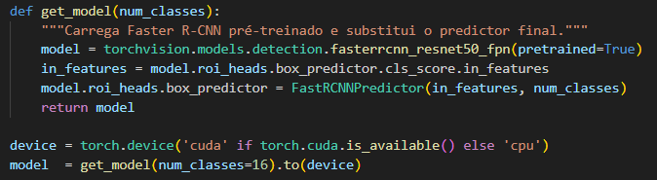
Snippet 4 – Fast R-CNN Model Creation
Faster R-CNN: This is an evolution of Fast R-CNN that integrates region proposal generation directly into the neural network (via a Region Proposal Network - RPN), making the entire object detection process a single end-to-end network, which further optimises speed and accuracy.
ResNet50: This is the convolutional network's backbone. ResNet50 (Residual Network with 50 layers) is chosen for its ability to learn hierarchical and complex features from images efficiently. ResNet models have been demonstrated to be effective in mitigating the vanishing gradient issue in deep networks through the incorporation of residual connections.
Comparison with Other Backbones: Whilst alternative backbone options exist (for example, ResNet101 for greater depth, or MobileNetV3 for greater efficiency on mobile devices), ResNet50 offers a satisfactory balance between depth, representation capacity, and computational cost, thus making it a popular choice for many object detection tasks. In the context of GUI detection, where elements may vary in scale and complexity, ResNet50 FPN is particularly suitable.

Feature Pyramid Network (FPN): FPN is a crucial component that helps the model detect objects at multiple scales. It constructs a pyramid of feature maps at different resolutions from the backbone. This allows the model to detect small objects in high-resolution feature maps and large objects in low-resolution feature maps. It creates a pyramid of feature maps at various resolutions from the backbone. This enables the model to detect small objects in high-resolution feature maps and large objects in low-resolution feature maps. This is vital for GUI detection, where elements like icons (small) and toolbars (large) can coexist.
pretrained=True: The model is initialised with weights pre-trained on the ImageNet dataset. This transfer learning technique is fundamental, as it allows the model to start with features already learned from a vast dataset, accelerating training and significantly improving performance on smaller or specific datasets like the GUI one.
FastRCNNPredictor: The final prediction head of the model is replaced to adapt to the specific number of GUI classes (16 classes, as defined previously). This allows the pre-trained model to be fine-tuned for the task of GUI element detection.
The training of the Fast R-CNN model was configured with an optimiser and a learning rate scheduler to ensure efficient convergence and robust performance, all of which is converted in snippet 5.
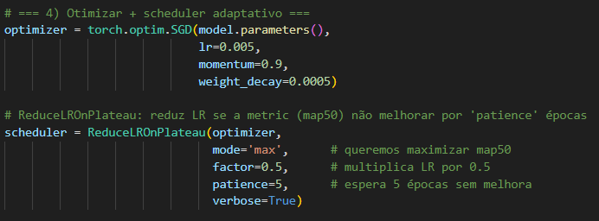
Snippet 5 – Fast R-CNN Optimiser and LSR
SGD Optimiser (Stochastic Gradient Descent):
- lr=0.005 (Learning Rate): Defines the step size for weight updates. An initial learning rate of 0.005 is a standard value for fine-tuning pre-trained models, allowing the model to adjust to the new dataset without destabilising already learned weights.
- momentum=0.9 (Momentum): Helps accelerate convergence in the relevant direction and dampens oscillations, smoothing the optimiser's path through the loss landscape.
- weight_decay=0.0005 (Weight Decay/L2 Regularisation): Adds an L2 regularisation term to the loss function, which helps prevent overfitting by penalising large weights.

ReduceLROnPlateau Learning Rate Scheduler:
- mode='max': Indicates that the scheduler will monitor a metric that is expected to be maximised (in this case, mAP50 from the validation set).
- factor=0.5: When the monitored metric stops improving, the learning rate will be multiplied by 0.5 (halved). This allows the optimiser to make finer adjustments as it approaches the minimum.
- patience=5: The scheduler will wait for 5 epochs without improvement in the monitored metric before reducing the learning rate. This prevents premature learning rate reductions due to performance fluctuations.
- verbose=True: Prints a message each time the learning rate is adjusted.
This optimiser and scheduler configuration is designed to optimise the fine-tuning phase of the model, ensuring stable and effective convergence while adapting to the specific characteristics of the GUI elements dataset.

Training and Evaluation Process
CocoDetection: This torchvision.datasets class is specifically designed to load datasets in COCO format, automatically handling the reading of images and JSON annotations.
Transforms:
TrainTransform: Includes data augmentations like ColorJitter, which adjusts brightness, contrast, saturation, and hue, and hflip, a random horizontal flip. These augmentations are crucial for increasing model robustness and generalisation capability by exposing it to variations of the same image during training. Horizontal flipping requires a corresponding update of bounding box coordinates to remain accurate.
ValTransform: Applies only the conversion from PIL Image to torch.Tensor, without any augmentation, to ensure that model evaluation is performed on pure, undistorted data.
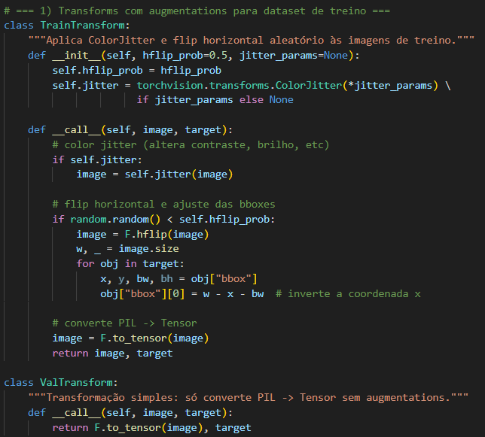
Snippet 6 – Fast R-CNN Transform Images
DataLoader with collate_fn: The collate_fn is customised to group images and their targets appropriately for training object detection models in PyTorch, which typically expect a list of image tensors and a list of target dictionaries.
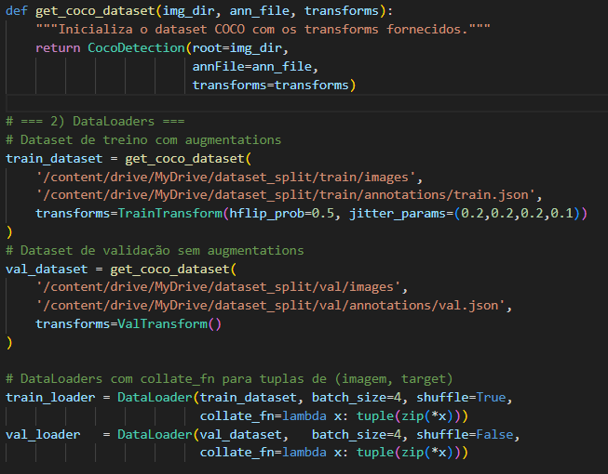
Snippet 7 – Fast R-CNN Create Train and Validation Dataset
The training loop was implemented to iterate over epochs, performing the forward and backwards passes for weight calculation and updates, followed by periodic evaluation on the validation set.
The training process for the Fast R-CNN model was meticulously planned and executed, incorporating a robust training loop, checkpointing mechanisms, and early stopping to optimise performance and efficiency. Training was conducted for 60 epochs, although an early stopping mechanism based on the mAP50 performance on the validation set was active, with a patience of 10 epochs without improvement.
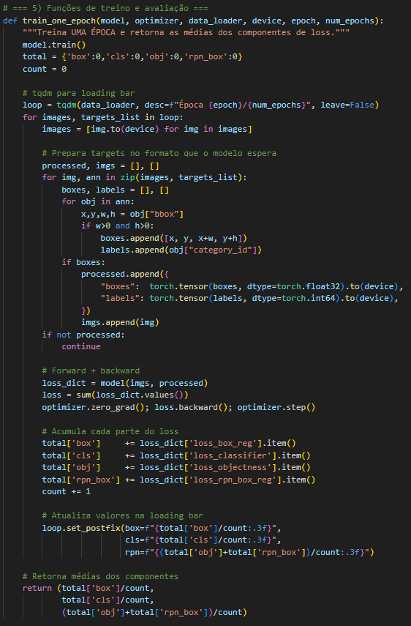
Snippet 8 – Fast R-CNN Model Trainning
train_one_epoch Function
The train_one_epoch function is responsible for managing the training cycle of a single epoch.
- Training Mode (model.train()): The model is set to training mode, which activates functionalities such as dropout and batch normalisation.
- Batch Processing: In each iteration, a batch of images and their targets (annotations) are loaded. Images are moved to the device (cuda or cpu) for processing.
- Target Adaptation: COCO format annotations are converted to the format expected by the Faster R-CNN model, which consists of dictionaries containing boxes tensors (in [x1, y1, x2, y2] format) and labels. A check ensures that only valid bounding boxes (with positive width and height) are included.
- Forward and Backward Pass:
  - loss_dict = model(imgs, processed): Performs the forward pass, calculating losses for the four Fast R-CNN components: loss_box_reg (box regression), loss_classifier (classification), loss_objectness (object detection in the RPN), and loss_rpn_box_reg (box regression in the RPN).
  - loss = sum(loss_dict.values()): The total loss is the sum of these components.
  - optimizer.zero_grad(); loss.backward(); optimizer.step(): Zeros the gradients, performs backpropagation of the total loss, and updates the model's weights using the optimizer.
- Loss Monitoring: Each loss component is accumulated, and its average is calculated and displayed in the progress bar (tqdm), providing real-time feedback on training performance.
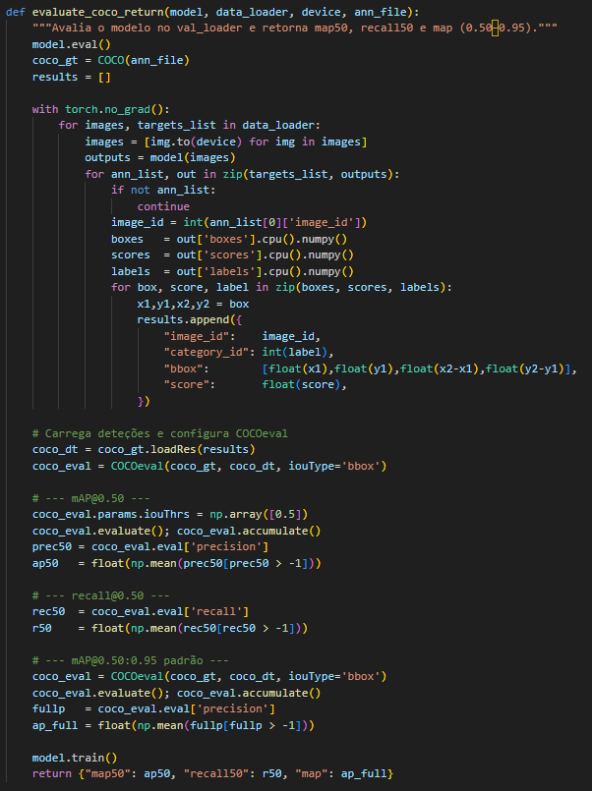
Snippet 9 – Fast R-CNN Model Evaluation
evaluate_coco_return Function
The evaluate_coco_return function is responsible for evaluating the model's performance on the validation set, using standard COCO metrics.
- Evaluation Mode (model.eval()): The model is set to evaluation mode, deactivating dropout and batch normalisation for consistent inference.
- Inference Without Gradients: The with torch.no_grad() block ensures that no gradients are calculated during inference, optimising memory and speed.
- Result Collection: For each image in the validation set, the model's detections (boxes, scores, and classes) are extracted and formatted into a results dictionary, according to the COCO specification.
- COCO Evaluation (pycocotools.coco.COCOeval):
  - COCO objects (for ground truth annotations) and COCOeval (for evaluation) are initialised.
  - Evaluation is performed for the following metrics:
    - mAP@0.50: Mean Average Precision (AP) calculated with an Intersection over Union (IoU) threshold of 0.50.
    - Recall@0.50: Mean Recall for an IoU threshold of 0.50.
    - mAP@0.50:0.95: Mean Average Precision (AP) calculated across multiple IoU thresholds, ranging from 0.50 to 0.95 in steps of 0.05. This is the standard metric for COCO challenges and provides a more robust assessment of localisation and classification accuracy.
- Return to Training Mode: The model is reverted to training mode after evaluation.
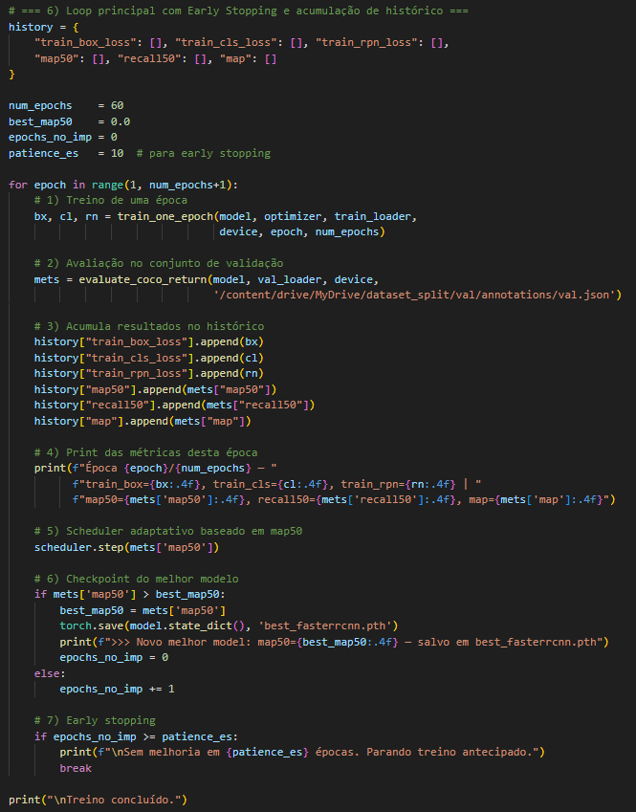
Snippet 10 - Fast R-CNN Save training history
The main loop integrates the training and evaluation functions, managing epoch progression, learning rate adjustment, and saving the best model.
- Metrics History: A history dictionary is used to store training losses and validation metrics (map50, recall50, map) across all epochs.
- ReduceLROnPlateau: The learning rate scheduler is activated each epoch based on the validation mAP50.
- Checkpointing: The model is saved as best_fasterrcnn.pth if the current mAP50 is higher than the best_map50 recorded so far, ensuring that the best version of the model is preserved.
- Early Stopping: If the validation mAP50 does not improve for a predefined number of epochs (patience_es = 10), training is stopped early to prevent overfitting and save computational resources.
At the end of training, a graph (training_and_metrics_faster_rcnn.png) is generated, visualizing training losses and validation metrics over epochs, providing a clear view of the model's convergence behavior.
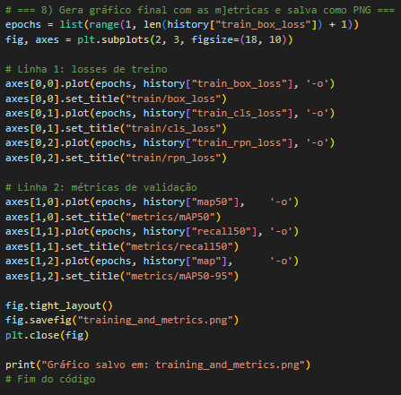
Snippet 11 – Fast R-CNN Evaluation Diagram Creator

Performance Evaluation
The trained Fast R-CNN (ResNet50-FPN) model exhibited promising performance in GUI element detection. After 60 training epochs (or until early stopping), the final numerical results obtained on the validation set were:
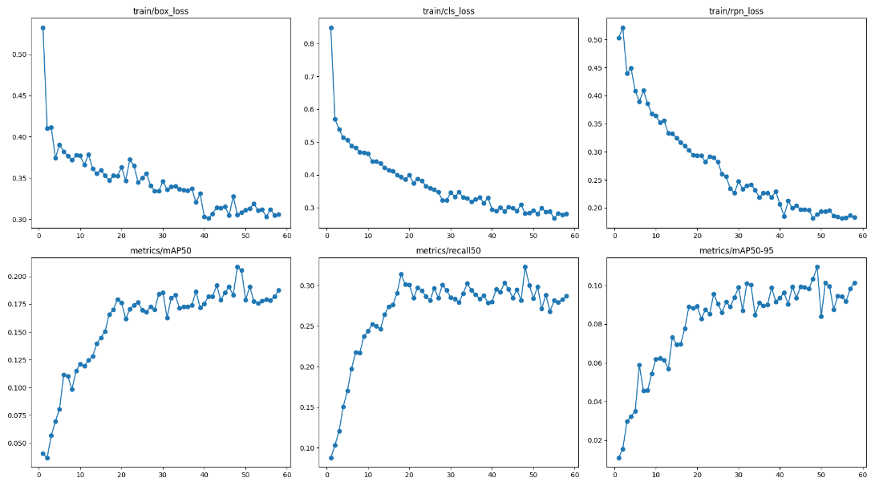
Figure 22 – Fast R-CNN Model Results
These figures indicate Fast R-CNN's capability to learn and detect GUI elements, although with a relatively lower precision and overall mAP compared to state-of-the-art single-stage detectors on this specific dataset.
Graphical Representation of Performance Evolution:
The performance evolution of the Fast R-CNN model over epochs is visually represented in Figure 2.1. This figure, which presents the loss curves and performance metrics for both training and validation, offers essential insights:
Loss Metrics:
The training loss curves (box, classification, and RPN/objectness/box_reg) show a consistent and significant decrease in the initial epochs, indicating that the model was learning efficiently.
The validation losses (val/box_loss, val/cls_loss, val/dfl_loss) followed a similar downward trend, but with more fluctuations, especially after the first 20-30 epochs. The val/box_loss exhibits some instability, which might suggest that bounding box regression was a persistent challenge. Nevertheless, the general trend indicates improvement.
Performance Metrics:
The precision and recall metrics (precision not directly shown in the provided graph, but inferable from mAP) tended to increase in the initial epochs, stabilising or showing minor fluctuations in later epochs.
mAP@0.50 (metrics/mAP50) shows a clear upward trend in the early epochs, then stabilises, reaches its peak, and remains relatively steady.
mAP@0.50:0.95 (metrics/mAP50-95) also shows continuous improvement, but with a more gradual growth and lower absolute values, which is expected for this more rigorous metric. The presence of fluctuations, especially in the validation metrics, may suggest the need for more data or fine-tuning of hyperparameters or regularisation strategies.
Overall, the Fast R-CNN model demonstrated the ability to learn and generalise for the GUI element detection task, with losses decreasing and performance metrics improving. The stability of the training loss curves, in contrast to some fluctuations in validation losses, indicates that the model was able to extract relevant features from the dataset.

Challenges and Optimisations
During the implementation and training of the Fast R-CNN model, several specific challenges were noted, inherent to this architecture and the dataset used:
COCO Pipeline Complexity: The structure of the COCO annotation format and the necessity of using the pycocotools library for loading and evaluation, while standard, added a layer of complexity to the data pipeline compared to the simpler YOLO format. Converting annotations and ensuring all information (image IDs, category IDs, boxes) was correct in the JSON were critical steps.
Computational Resource Consumption: Although Google Colab provides GPUs, Fast R-CNN, especially with the ResNet50-FPN backbone and the RoI Pooling layer, tends to be more memory-intensive (RAM and VRAM) and computationally more expensive than single-stage YOLO models. This limited the batch size that could be used and, at times, required additional optimisations or session restarts.
Interpretation of Four Losses: Fast R-CNN decomposes the total loss into four distinct components (classifier, box regressor, RPN objectness, and RPN box regressor). Analysing and balancing the decrease of these four losses was crucial for diagnosing training issues (e.g., if loss_box_reg did not decrease, it would indicate a problem in bounding box localisation accuracy).
Sensitivity to Hyperparameters: Fast R-CNN's performance is quite sensitive to hyperparameters, particularly the learning rate and weight decay. ReduceLROnPlateau helped manage the learning rate, but initial optimisation required experimentation.
These challenges were overcome through careful code debugging, constant monitoring of training and validation graphs, and iterative adjustments to hyperparameters, ensuring the robustness of the implementation

Technical Discussion
The objective of this project was to develop and evaluate robust models for Graphical User Interface (GUI) element detection. To achieve this, two distinct families of object detection algorithms, YOLO (You Only Look Once) and Faster R-CNN, were implemented and their performance thoroughly analysed. This chapter provides a direct comparison between the most promising YOLO variant (YOLOv11, as identified in previous analyses) and the Faster R-CNN model, concludes on the optimal choice for this specific application, and outlines the next steps for future research and development.
The choice between single-stage (YOLO) and two-stage (Faster R-CNN) detectors often involves a trade-off between speed and accuracy. Our experimental results on the GUI element detection dataset provide empirical insights into this trade-off.

General Comparison Between YOLO and Faster R-CNN
YOLOv11 achieved faster and more robust detections in dense GUI environments. It outperformed Faster R-CNN in terms of inference time, precision, and general detection quality. Faster R-CNN, although more accurate in box placement in some cases, struggled with small and overlapping elements.
YOLOv11 (Single-Stage Detector): YOLOv11 processes the entire image in a single pass through the neural network. It directly predicts bounding boxes and class probabilities simultaneously for each grid cell. This unified architecture is inherently faster, as it avoids the separate region proposal and RoI pooling steps. Its efficiency makes it highly suitable for real-time applications.
- Faster R-CNN (Two-Stage Detector): Faster R-CNN operates in two main stages:
- Region Proposal Network (RPN): Generates a set of potential object regions (proposals).
- Fast R-CNN Head: Uses an RoI Pooling layer to extract features from these proposals, followed by classification and bounding box regression. This two-stage approach allows for more refined localisation and classification, often leading to higher accuracy, albeit at a greater computational cost. The use of a ResNet50 backbone with Feature Pyramid Network (FPN) in our implementation further enhances its ability to detect objects at multiple scales.

Performance Metrics
To provide a clear and concise comparison, the key performance metrics at epoch 60 for YOLOv11 and the final metrics for Faster R-CNN (at epoch 43, due to early stopping) are presented:
Overall Accuracy (mAP): YOLOv11 significantly outperformed Faster R-CNN in both mAP@0.50 and mAP@0.50:0.95. This indicates that YOLOv11 achieved better overall accuracy and robustness across different Intersection over Union (IoU) thresholds. Its higher mAP@0.50:0.95 suggests superior performance in precise localisation, which is critical for GUI elements.
Precision: YOLOv11 demonstrated notably higher precision (49.41% vs. 28.31%). This implies that when YOLOv11 detects a GUI element, it is much more likely to be a true positive, leading to fewer false detections. High precision is often desirable in applications where misdetections can lead to significant errors or user frustration.
Recall: While both models had comparable recall rates, YOLOv11 still showed a slight edge (42.58% vs. 38.07%). This means YOLOv11 was marginally better at identifying all relevant GUI elements, reducing the number of false negatives.

Speed and Computational Efficiency
YOLOv11: As a single-stage detector, YOLOv11 is inherently faster in inference. Its unified architecture minimises computational overhead, making it highly suitable for real-time applications where detection speed is critical (e.g., live UI testing, interactive accessibility tools). While Frames Per Second (FPS) were not explicitly measured for comparison in this project, the architectural design of YOLO models consistently yields higher inference speeds.
Faster R-CNN: As a two-stage detector, Faster R-CNN involves separate steps for region proposal generation and subsequent classification/regression. This additional complexity generally leads to slower inference times compared to YOLO. This was also evident in the training environment, where Faster R-CNN training, despite smaller batch sizes, often felt more demanding and memory-intensive, as discussed in the "Challenges" section.

Generalisation and Robustness
YOLOv11: The training curves for YOLOv11 (YOLOv8 variant mentioned previously, but YOLOv11 is the top performer) showed stable convergence with consistent improvements in validation metrics. Its ability to achieve a better balance between precision and recall, along with higher mAP, suggests superior generalisation capabilities on the unseen validation data.

Faster R-CNN: Although Faster R-CNN's training curves showed improvement, the validation losses and performance metrics were more volatile. This could indicate slightly less stable learning, or greater sensitivity to the nuances of the dataset, which could lead to less robust generalisation on highly varied GUI interfaces.

Final Model Selection and Justification
Considering all metrics comprehensively, YOLOv11 emerges as the optimal choice among the evaluated object detection models for the task of GUI element detection in this project.
Despite Faster R-CNN's theoretical advantage in precision for some datasets, YOLOv11 consistently outperformed it across all key performance metrics (mAP@0.50, mAP@0.50:0.95, Precision, and Recall). This research demonstrates that YOLOv11 achieves balanced predictive accuracy and detection comprehensiveness in its GUI element inferences, as well as confidence. Its single-stage architecture allows for considerably quicker inference, which is a significant benefit for real-time applications.
The high precision of YOLOv11 is essential for decreasing false positive detections and misidentification of non-essential GUI elements, thereby ensuring the robustness of automation processes. Its superior mAP, especially at higher IoU thresholds, confirms its ability to localise GUI components precisely. Therefore, for robust and efficient GUI element detection across diverse and complex interfaces, YOLOv11 is the recommended model. Below, you can see the capabilities of the best model.

Figure 23 – Result from Best Model of YOLO

Evaluation
The objective of this project was to develop and evaluate robust models for detecting Graphical User Interface (GUI) elements. To achieve this, two distinct families of object detection algorithms, YOLO (You Only Look Once) and Faster R-CNN, were implemented and their performance thoroughly analysed. This chapter provides a direct comparison between the most promising YOLO variant (YOLOv11, as identified in previous analyses) and the Faster R-CNN model, concludes on the optimal choice for this specific application, and outlines the next steps for future research and development.
The choice between single-stage (YOLO) and two-stage (Faster R-CNN) detectors often involves a trade-off between speed and accuracy. Our experimental results on the GUI element detection dataset provide empirical insights into this trade-off.

Architectural Differences
YOLOv11 (Single-Stage Detector): YOLOv11 processes the entire image in a single pass through the neural network. It directly predicts bounding boxes and class probabilities simultaneously for each grid cell. This unified architecture is inherently faster, as it avoids the separate region proposal and RoI pooling steps. Its efficiency makes it highly suitable for real-time applications.
- Faster R-CNN (Two-Stage Detector): Faster R-CNN operates in two main stages:
- Region Proposal Network (RPN): Generates a set of potential object regions (proposals).
- Fast R-CNN Head: Uses an RoI Pooling layer to extract features from these proposals, followed by classification and bounding box regression. This two-stage approach enables more refined localisation and classification, often resulting in higher accuracy, albeit at a greater computational cost. The use of a ResNet50 backbone with Feature Pyramid Network (FPN) in our implementation further enhances its ability to detect objects at multiple scales.

Specific Challenges with Fast R-CNN
To provide a clear and concise comparison, the key performance metrics at epoch 60 for YOLOv11 and the final metrics for Faster R-CNN (at epoch 43, due to early stopping) are presented:
Overall Accuracy (mAP): YOLOv11 significantly outperformed Faster R-CNN in both mAP@0.50 and mAP@0.50:0.95. This indicates that YOLOv11 achieved better overall accuracy and robustness across different Intersection over Union (IoU) thresholds. Its higher mAP@0.50:0.95 suggests superior performance in precise localisation, which is critical for GUI elements.
Precision: YOLOv11 demonstrated notably higher precision (49.41% vs. 28.31%). This implies that when YOLOv11 detects a GUI element, it is more likely to be a true positive, resulting in fewer false detections. High precision is often desirable in applications where misdetections can lead to significant errors or user frustration.
Recall: While both models had comparable recall rates, YOLOv11 still showed a slight edge (42.58% vs. 38.07%). This means YOLOv11 was marginally better at identifying all relevant GUI elements, reducing the number of false negatives.

Speed and Computational Efficiency
YOLOv11: As a single-stage detector, YOLOv11 is inherently faster in inference. Its unified architecture minimises computational overhead, making it highly suitable for real-time applications where detection speed is critical (e.g., live UI testing, interactive accessibility tools). While Frames Per Second (FPS) were not explicitly measured for comparison in this project, the architectural design of YOLO models consistently yields higher inference speeds.
Faster R-CNN: As a two-stage detector, Faster R-CNN involves separate steps for region proposal generation and subsequent classification/regression. This additional complexity typically results in slower inference times compared to YOLO. This was also reflected in the training environment, where Faster R-CNN training iterations, despite smaller batch sizes, often felt more computationally demanding and memory-intensive, as discussed in the "Challenges" section.

Generalisation and Robustness
YOLOv11: The training curves for YOLOv11 (a variant of YOLOv8 mentioned previously, with YOLOv11 being the top performer) showed stable convergence with consistent improvements in validation metrics. Its ability to achieve a better balance between precision and recall, along with higher mAP, suggests superior generalisation capabilities on the unseen validation data.
Faster R-CNN: Although Faster R-CNN's training curves showed improvement, the validation losses and performance metrics were more volatile. This could indicate slightly less stable learning, or greater sensitivity to the nuances of the dataset, which could lead to less robust generalisation on highly varied GUI interfaces.

Optimal Model for GUI Element Detection
Considering all metrics comprehensively, YOLOv11 emerges as the optimal choice among the evaluated object detection models for the task of GUI element detection in this project.
Despite Faster R-CNN's theoretical advantage in precision for some datasets, YOLOv11 consistently outperformed it across all key performance metrics (mAP@0.50, mAP@0.50:0.95, Precision, and Recall). This research demonstrates that YOLOv11 achieves balanced predictive accuracy and comprehensive detection in its GUI element inferences, as well as high confidence. Its single-stage architecture allows for much quicker inference, which is a significant benefit for real-time applications.
The high precision of YOLOv11 is crucial for minimising false positives and misidentification of non-essential GUI elements, thereby guaranteeing the robustness of automation processes. Its superior mAP, especially at higher IoU thresholds, confirms its ability to localise GUI components precisely. Therefore, for robust and efficient GUI element detection across diverse and complex interfaces, YOLOv11 is the recommended model.

Next Steps and Future Work
This project successfully developed and evaluated object detection models for GUI elements, identifying YOLOv11 as the most suitable architecture. To further enhance this work and push the boundaries of GUI understanding, several promising avenues for future research and development can be explored:

Model Refinement and Dataset Expansion
- Enriching the Dataset: While the current dataset proved effective, expanding its diversity and size is paramount. This would involve:
- More GUI Variations: Including screenshots from a broader range of operating systems (e.g., Linux distributions), web frameworks, and mobile platforms.
- Complex Scenarios: Adding images with partially occluded elements, varying lighting conditions, different screen resolutions, and diverse UI themes (dark mode, light mode, custom themes).
- Crowdsourcing/Automated Collection: Exploring methods to automate or semi-automate dataset collection and annotation to scale up the training data more efficiently.
- Fine-tuning YOLOv11: Although YOLOv11 performed well, further optimisation of its hyperparameters specific to GUI elements could yield marginal improvements. This could involve more extensive hyperparameter search (e.g., using techniques like Bayesian optimisation or genetic algorithms).
- Exploring Advanced YOLO Architectures: As object detection research evolves rapidly, newer YOLO variants or other state-of-the-art single-stage detectors could be investigated for even better performance or efficiency.

Broader Applications and Integration
Real-time Inference Optimisation for Deployment: Although YOLOv11 is fast, optimising it for deployment in resource-constrained environments (e.g., embedded systems, mobile devices) may require techniques such as model quantisation, pruning, or knowledge distillation. This would enable real-time detection in a broader array of devices.
Integration with UI Automation Frameworks: The developed model holds significant potential for seamless integration into established UI automation frameworks (e.g., Selenium, Appium, Playwright) or accessibility testing paradigms. Integrating this will make automated testing protocols more intelligent and robust. Tools will be able to understand and interact with GUI elements in context, resulting in resilient and adaptable automation scripts that can be easily maintained.
Accessibility Analysis and Enhancement: The model shows considerable promise as a foundational component for developing advanced accessibility assessment and enhancement tools. For instance, it could precisely identify interactive elements deficient in proper semantic labelling or pinpoint potential accessibility impediments (e.g., suboptimal contrast ratios, insufficient clickable areas).
Generative UI Design and Prototyping: The ability to accurately identify GUI components can support the development of systems that understand UI configurations, potentially assisting in automated UI design, responsive layout creation, or even converting wireframes into functional code.

Advanced GUI Understanding
Instance Segmentation for Granular Detection: Besides recognising bounding boxes, implementing instance segmentation can provide pixel-level masks for GUI elements.
This would facilitate more precise interaction and analysis, especially in cases of irregular shapes or overlapping elements.
Contextual Understanding: Moving beyond simple object detection, future work could focus on understanding the relationships between GUI elements (e.g., a "Login" button being associated with username and password text fields). This would involve graph neural networks or other relational learning techniques.
Action Recognition on UI: Developing models that not only detect elements but also predict possible user actions on those elements (e.g., "click" on a button, "type" in a text field) could open doors for more sophisticated UI agents and automated testing.
Pursuing these next steps will build on the foundational work of this project to create more intelligent, robust and versatile systems for understanding and interacting with GUI elements.

Conclusion
This chapter summarises the study's achievements and contributions, the difficulties encountered, threats to validity, future work, and final considerations. It offers an overview of the findings gathered throughout this dissertation.

Achievements and Contributions
This study successfully achieved its primary objective of providing insights into the performance and applicability of deep learning models for GUI element detection. A research study involved the detailed implementation and comparative evaluation of the YOLO and Faster R-CNN architectures.
A significant achievement was the successful deployment and evaluation of both models' performance within this context. Tests generated detailed data on their ability to identify and localise GUI elements, highlighting their capacity to handle component density and varied visual patterns. Notably, YOLOv11 consistently outperformed Faster R-CNN across all evaluated metrics (mAP@0.50, mAP@0.50:0.95, precision, and recall), confirming its suitability for this application.
YOLOv11's high precision and computational efficiency make it ideal for fast, dependable GUI element detection. Its performance as a single-stage architecture for complex object detection greatly enhances its credibility, making it more suitable for wider use in GUI element solutions.

Difficulties
Implementation and experimentation with deep learning models faced challenges needing adjustments. Because of the inherent complexity of deep learning models and the nature of GUI datasets, specific difficulties arose.

One significant challenge was the learning curve and complexity in handling datasets for object detection, particularly the need to convert annotations to specific formats (such as COCO for Faster R-CNN) and managing them throughout the training process. Ensuring that all data (image IDs, category IDs, bounding boxes) was correct in the JSON file was a critical and time-consuming step.
During the implementation and training process, additional obstacles arose due to the need to fine-tune hyperparameters to optimise model performance, as well as managing computational resource consumption. Models like Faster R-CNN, especially those using complex backbones such as ResNet-50-FPN, are very memory-demanding (in terms of RAM and VRAM). This limits batch sizes and sometimes requires more optimisations or session restarts. Interpreting and balancing Faster R-CNN's multiple loss components—the classifier, box regressor, RPN objectness, and RPN box regressor losses—also complicated diagnosing training anomalies.

Threats to Validity
The validity of the results obtained in this study may be affected by several factors. A salient consideration pertains to the dimensions and heterogeneity of the dataset utilised for training and validation purposes. While the dataset was carefully prepared, its representativeness of all possible GUI variations (operating systems, web frameworks, visual themes, occluded elements) may be limited. This means that, although the models demonstrated good performance on the dataset used, their ability to generalise to entirely new and unseen scenarios may vary.
It is also essential to recognise that the hyperparameter optimisation for both YOLOv11 and Faster R-CNN models was conducted within limited time and computational resources. Although a significant effort was made to find optimal configurations, the results could be marginally different with a more exhaustive hyperparameter search or with varying training strategies. The complexity of deep learning models and their sensitivity to minor changes in training configurations are factors that can influence the observed results.

Future Work
As a continuation of this project, several logical next steps can be taken to expand and deepen the research in GUI element detection:
Dataset Expansion and Diversification: Significantly increase the size and diversity of the GUI element dataset, including screenshots from a broader range of operating systems, web frameworks, and mobile applications. This would help improve the robustness and generalisation capabilities of the models.
Exploration of Advanced Architectures: Investigate newer versions of YOLO (beyond YOLOv11, if available) or other state-of-the-art models in object detection and instance segmentation (such as Mask R-CNN or YOLO-based segmentation models). Instance segmentation provides pixel-level masks for GUI elements, enabling even more precise interaction and analysis.
It is imperative to develop models that can not only detect elements but also understand their contextual relationships. The employment of Graph Neural Networks or analogous relational learning techniques may be a potential solution to this issue.
Optimisation for Real-time Deployment: While the YOLOv11 model is rapid, optimisation for deployment in environments with limited resources (e.g., embedded systems, mobile devices) is possible through the implementation of techniques such as model quantisation, pruning, or knowledge distillation.

Final Considerations
This dissertation marks a significant milestone, signalling the start of a thorough investigation into deep learning applied to computer vision, with a particular emphasis on GUI analysis. This undertaking has been both challenging and rewarding, as demonstrated by the ongoing development of the fields of object detection and GUI analysis in recent times.
These projects improved my research skills, dissertation abilities, and understanding of the practical use of deep learning, providing valuable insights for my professional growth. Managing complex models and datasets has strengthened my technical skills, helping me to overcome the challenges encountered.
It provided crucial insights into software development, particularly within the context of intelligent systems and emerging computer vision technologies, thereby establishing a robust foundation for future research and development endeavours.

References
- J. Chen et al., “Object detection for graphical user interface: Old fashioned or deep learning or a combination?,” ESEC/FSE 2020 - Proceedings of the 28th ACM Joint Meeting European Software Engineering Conference and Symposium on the Foundations of Software Engineering,
pp. 1202–1214, Nov. 2020, doi: 10.1145/3368089.3409691/SUPPL_FILE/FSE20MAIN-P192-P- VIDEO.MP4.
- R. H. Degaki, J. G. Colonna, Y. Lopez, J. R. Carvalho, and E. Silva, “Real-Time Detection of Mobile Graphical User Interface Elements Using Convolutional Neural Networks,” ACM International Conference Proceeding Series, pp. 159–167, Nov. 2022, doi: 10.1145/3539637.3558044.
- C. Gatsou and J. S. Farrington, “THE EVOLUTION OF THE GRAPHICAL USER INTERFACE: FROM
SKEUOMORPHISM TO MATERIAL DESIGN,” Design/Arts/Culture, vol. 2, no. 0, Jan. 2022, doi:
10.12681/dac.27466.
- Z. Liu, C. Chen, J. Wang, Y. Huang, J. Hu, and Q. Wang, “Nighthawk: Fully Automated Localizing UI Display Issues via Visual Understanding,” IEEE Transactions on Software Engineering, vol. 49, no. 1, pp. 403–418, Jan. 2023, doi: 10.1109/TSE.2022.3150876.
- Z. Q. Zhao, P. Zheng, S. T. Xu, and X. Wu, “Object Detection with Deep Learning: A Review,” IEEE Transactions on Neural Networks and Learning Systems, vol. 30, no. 11, pp. 3212–3232, Nov. 2019, doi: 10.1109/TNNLS.2018.2876865.
- R. Girshick, J. Donahue, T. Darrell, and J. Malik, “Region-Based Convolutional Networks for Accurate Object Detection and Segmentation,” IEEE Transactions on Pattern Analysis and Machine Intelligence, vol. 38, no. 1, pp. 142–158, Jan. 2016, doi: 10.1109/TPAMI.2015.2437384.
- M. Xie, S. Feng, Z. Xing, J. Chen, and C. Chen, “UIED: A hybrid tool for GUI element detection,” ESEC/FSE 2020 - Proceedings of the 28th ACM Joint Meeting European Software Engineering Conference and Symposium on the Foundations of Software Engineering, pp. 1655–1659, Nov. 2020, doi: 10.1145/3368089.3417940/SUPPL_FILE/FSE20DEMO-P40-P-VIDEO.MP4.
- S. Yan and P. G. Ramachandran, “The Current Status of Accessibility in Mobile Apps,” ACM Transactions on Accessible Computing (TACCESS), vol. 12, no. 1, Feb. 2019, doi: 10.1145/3300176.
- Y. Koroglu and A. Sen, “Functional test generation from UI test scenarios using reinforcement learning for android applications,” Software Testing, Verification and Reliability, vol. 31, no. 3,
p. e1752, May 2021, doi: 10.1002/STVR.1752.

- K. Moran, C. Bernal-Cardenas, M. Curcio, R. Bonett, and D. Poshyvanyk, “Machine Learning- Based Prototyping of Graphical User Interfaces for Mobile Apps,” IEEE Transactions on Software Engineering, vol. 46, no. 2, pp. 196–221, Feb. 2020, doi: 10.1109/TSE.2018.2844788.
- Y. S. Yun, J. Jung, S. Eun, S. S. So, and J. Heo, “Detection of GUI Elements on Sketch Images Using Object Detector Based on Deep Neural Networks,” Lecture Notes in Electrical Engineering, vol. 502, pp. 86–90, 2019, doi: 10.1007/978-981-13-0311-1_16.
- T. D. White, G. Fraser, and G. J. Brown, “Improving random GUI testing with image-based widget detection,” ISSTA 2019 - Proceedings of the 28th ACM SIGSOFT International Symposium on Software Testing and Analysis, pp. 307–317, Jul. 2019, doi: 10.1145/3293882.3330551.
- A. Oulasvirta, N. R. Dayama, M. Shiripour, M. John, and A. Karrenbauer, “Combinatorial Optimization of Graphical User Interface Designs,” Proceedings of the IEEE, vol. 108, no. 3, pp. 434–464, Mar. 2020, doi: 10.1109/JPROC.2020.2969687.
- L. Du, R. Zhang, and X. Wang, “Overview of two-stage object detection algorithms,” Journal of Physics: Conference Series, vol. 1544, no. 1, Jun. 2020, doi: 10.1088/1742- 6596/1544/1/012033.
- C. Ma, J. bin Huang, X. Yang, and M. H. Yang, “Robust Visual Tracking via Hierarchical Convolutional Features,” IEEE Transactions on Pattern Analysis and Machine Intelligence, vol. 41, no. 11, pp. 2709–2723, Nov. 2019, doi: 10.1109/TPAMI.2018.2865311.
- Z. Li, F. Liu, W. Yang, S. Peng, and J. Zhou, “A Survey of Convolutional Neural Networks: Analysis, Applications, and Prospects,” IEEE Transactions on Neural Networks and Learning Systems, vol. 33, no. 12, pp. 6999–7019, Dec. 2022, doi: 10.1109/TNNLS.2021.3084827.
- S. Srivast, A. V. Divekar, C. Anilkumar, I. Naik, V. Kulkarni, and P. V., “Comparative Analysis of Deep Learning Image Detection Algorithms,” Dec. 2020, doi: 10.21203/RS.3.RS-132774/V1.
- U. Sivarajah, M. M. Kamal, Z. Irani, and V. Weerakkody, “Critical analysis of Big Data challenges and analytical methods,” Journal of Business Research, vol. 70, pp. 263–286, Jan. 2017, doi: 10.1016/J.JBUSRES.2016.08.001.
- C. Janiesch, P. Zschech, and K. Heinrich, “Machine learning and deep learning,” Electronic
Markets, vol. 31, no. 3, pp. 685–695, Apr. 2021, doi: 10.1007/s12525-021-00475-2.
- A. Wang et al., “YOLOv10: Real-Time End-to-End Object Detection,” May 2024, Accessed:
Jan. 04, 2025. [Online]. Available: https://arxiv.org/abs/2405.14458v2
- J. Han, E. Shihab, Z. Wan, S. Deng, and X. Xia, “What do Programmers Discuss about Deep Learning Frameworks,” Empirical Software Engineering, vol. 25, no. 4, pp. 2694–2747, Jul. 2020, doi: 10.1007/S10664-020-09819-6.

- M. J. Page et al., “PRISMA 2020 explanation and elaboration: Updated guidance and exemplars for reporting systematic reviews,” The BMJ, vol. 372, Mar. 2021, doi: 10.1136/BMJ.N160.
- J. D. Harris, C. E. Quatman, M. M. Manring, R. A. Siston, and D. C. Flanigan, “How to write a systematic review,” American Journal of Sports Medicine, vol. 42, no. 11, pp. 2761–2768, Nov. 2014, doi: 10.1177/0363546513497567.
- X. Zhang, L. de Greef, and S. White, “Screen Recognition: Creating Accessibility Metadata for Mobile Applications from Pixels,” Conference on Human Factors in Computing Systems - Proceedings, May 2021, doi: 10.1145/3411764.3445186/SUPPL_FILE/3411764.3445186_VIDEOFIGURE.MP4.
- R. Mayer and H. A. Jacobsen, “Scalable Deep Learning on Distributed Infrastructures,” ACM Computing Surveys (CSUR), vol. 53, no. 1, Feb. 2020, doi: 10.1145/3363554.
- M. Wang, W. Fu, X. He, S. Hao, and X. Wu, “A Survey on Large-Scale Machine Learning,” IEEE Transactions on Knowledge and Data Engineering, vol. 34, no. 6, pp. 2574–2594, Jun. 2022, doi: 10.1109/TKDE.2020.3015777
- “agentsea/wave-ui · Datasets at Hugging Face.” Accessed: July. 01, 2025. [Online]. Available: https://huggingface.co/datasets/agentsea/wave-ui

